KUSH BHARDWAJ

SECTION – Q

ROLL NO. 37

1–

#include <stdio.h>

int main()

{

int num1, num2;

int sum, sub, mult, mod;

float div;

printf("Enter any two numbers: ");

scanf("%d%d", &num1, &num2);

sum = num1 + num2;

sub = num1 - num2;

mult = num1 * num2;

div = (float)num1 / num2;

mod = num1 % num2;

printf("SUM = %d\n", sum);

printf("DIFFERENCE = %d\n", sub);

printf("PRODUCT = %d\n", mult);

printf("QUOTIENT = %f\n", div);

printf("MODULUS = %d", mod);

return 0;

}

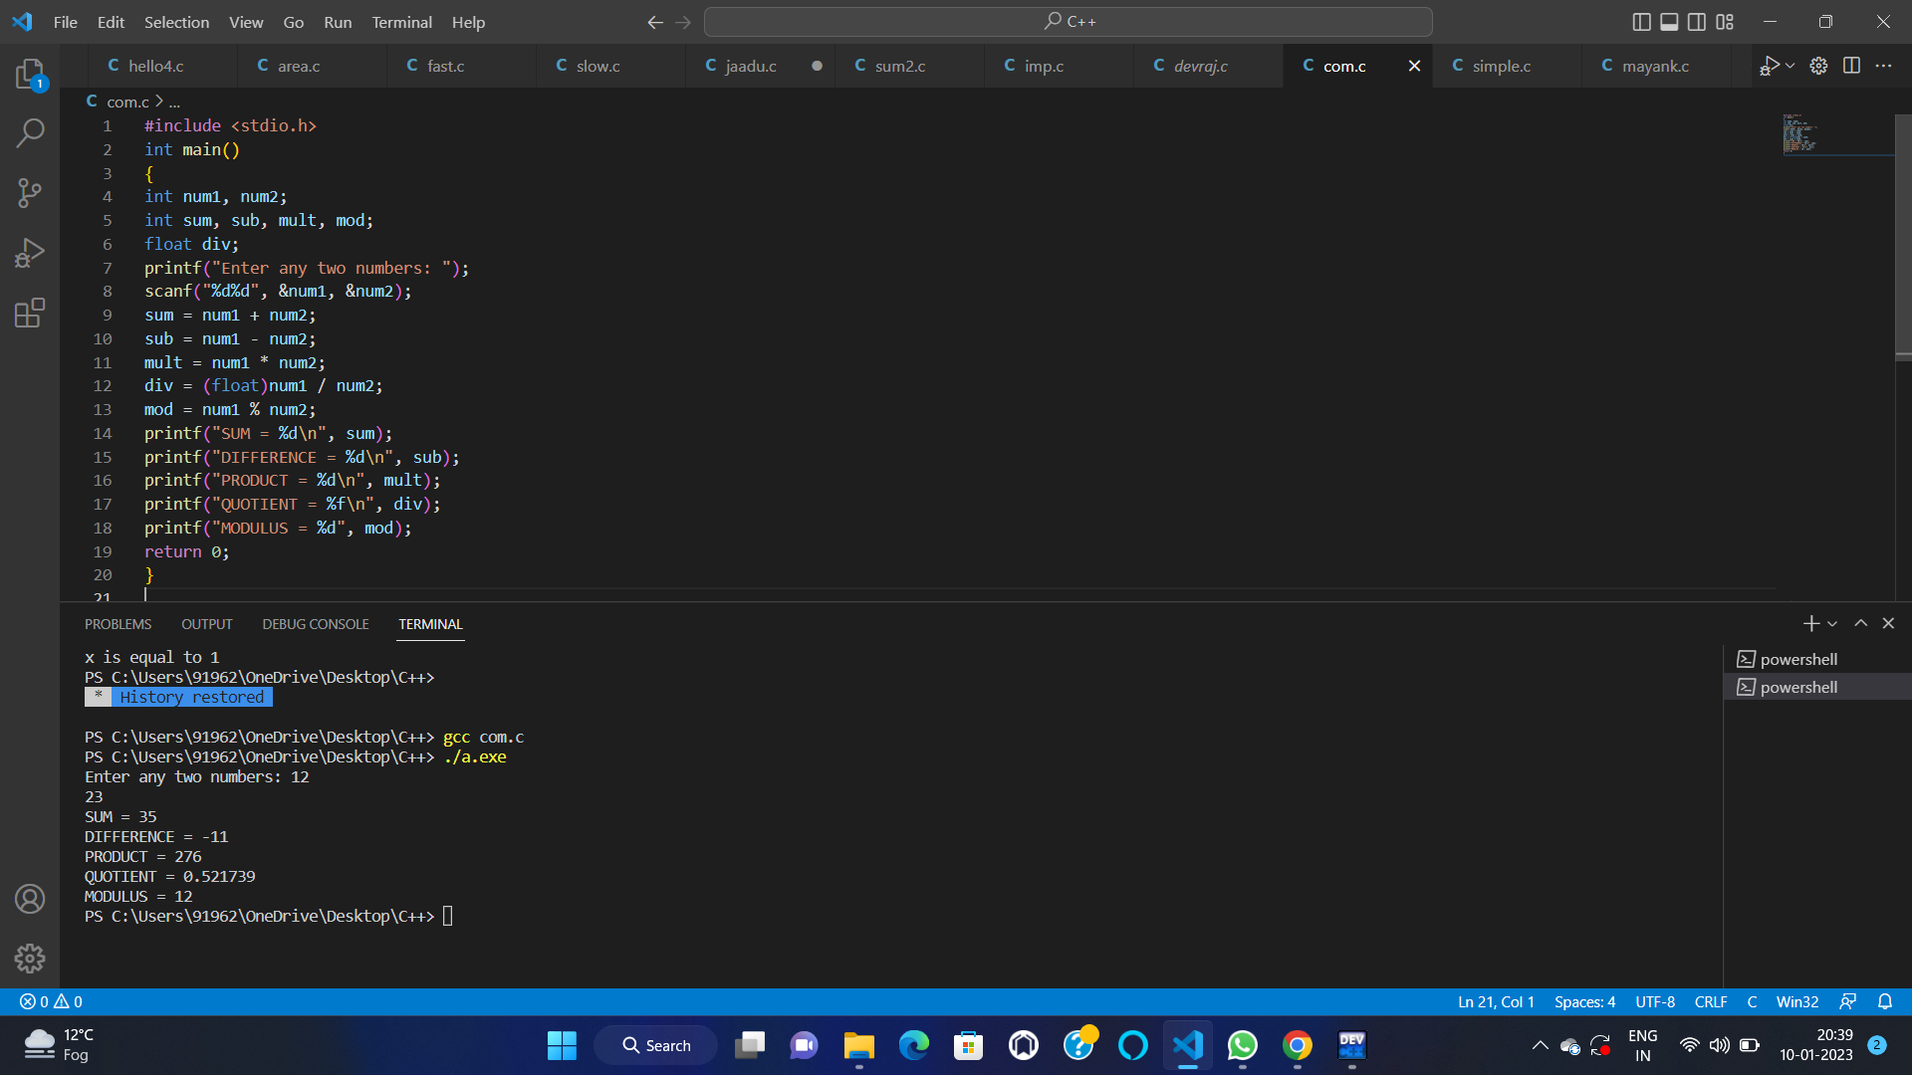

2

–

#include <stdio.h>

int main()

{

float base, height, area;

printf("Enter base of the triangle: ");

scanf("%f", &base);

printf("Enter height of the triangle: ");

scanf("%f", &height);

area = (base * height) / 2;

printf("Area of the triangle = %.2f sq. units", area);

return 0;

}

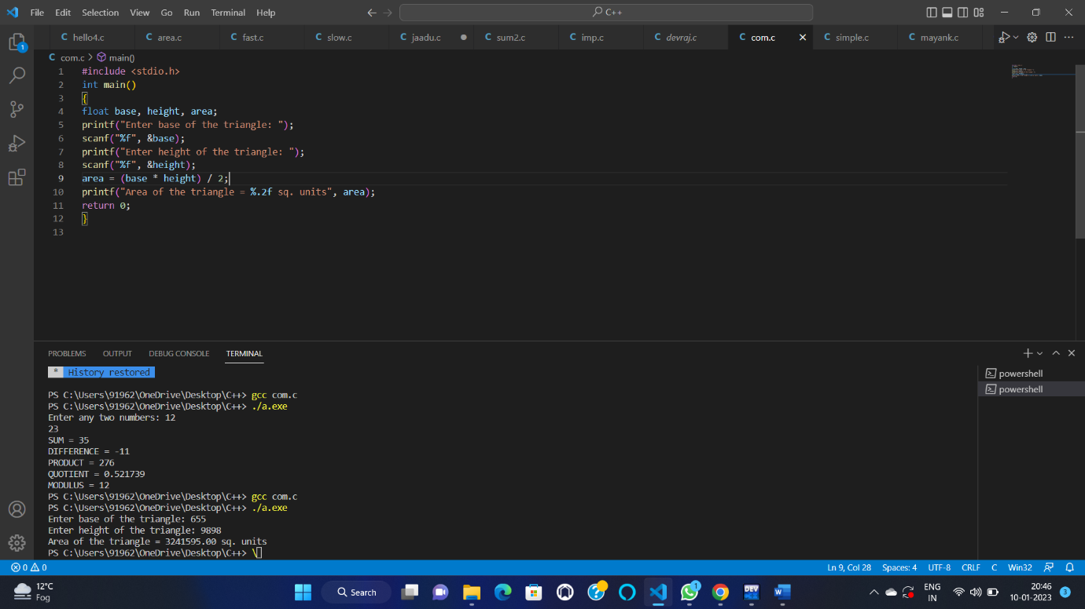

3–

#include <stdio.h>

int main()

{

int a, b, c;

printf("Enter two angles of triangle: ");

scanf("%d%d", &a, &b);

c = 180 - (a + b);

printf("Third angle of the triangle = %d", c);

return 0;

}

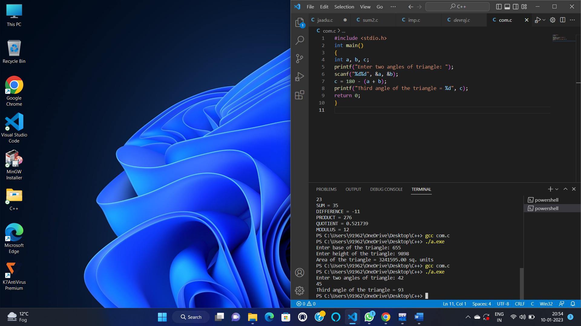

4--

#include <stdio.h>

int main()

{

int days, years, weeks;

printf("Enter days: ");

scanf("%d", &days);

years = (days / 365);

weeks = (days % 365) / 7;

days = days - ((years * 365) + (weeks * 7));

printf("YEARS: %d\n", years);

printf("WEEKS: %d\n", weeks);

printf("DAYS: %d", days);

return 0;

}

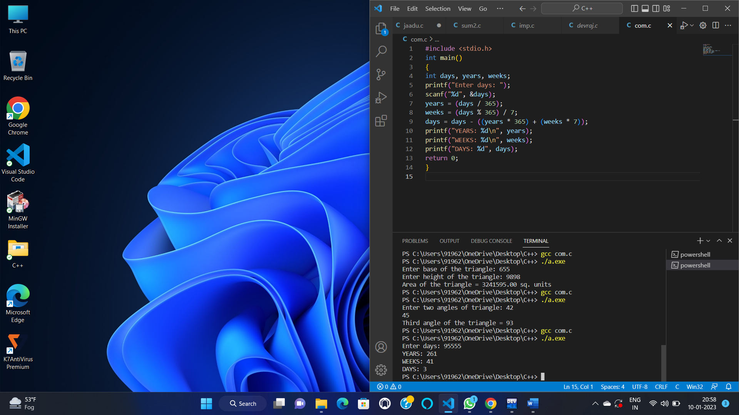

5–

#include <stdio.h>#include <math.h>int main(){ int sq,x,pw;

printf("enter the value\n "); scanf("%d",&x); printf("enter the pow\n"); scanf("%d",&pw); int a=sqrt(x); int b=pow(x,pw); printf("THE SQUARE ROOT OF GIVEN NUM IS %d\n THE POWER OF GIVEN NUM IS %d",a,b); return 0;}

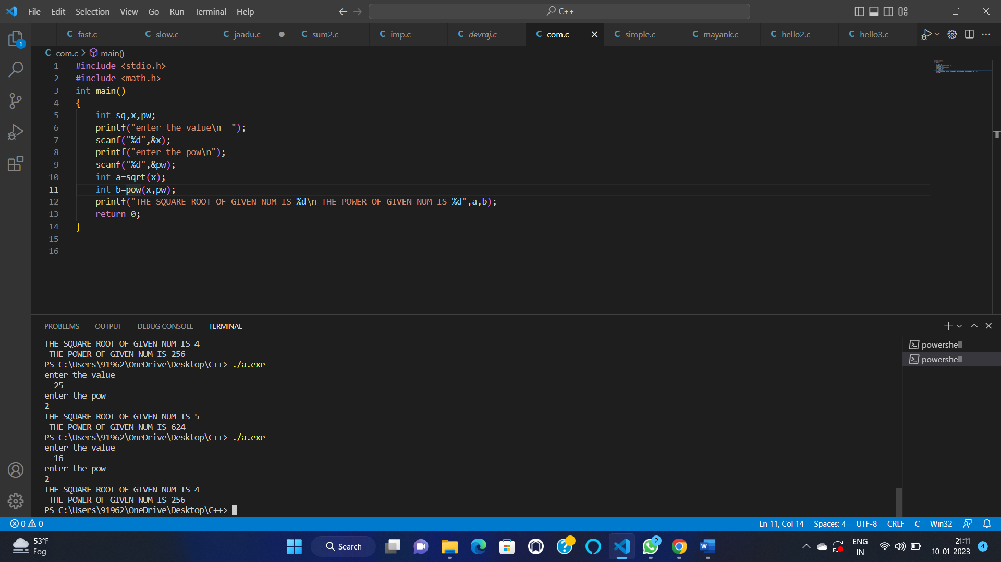

6—

#include <stdio.h>

int main()

{

float eng, phy, chem, math, comp;

float total, average, percentage;

printf("Enter marks of five subjects: :- ");

scanf("%f%f%f%f%f", &eng, &phy, &chem, &math, &comp);

total = eng + phy + chem + math + comp;

average = total / 5.0;

percentage = (total / 500.0) * 100;

printf("Total marks = %.2f\n", total);

printf("Average marks = %.2f\n", average);

printf("Percentage = %.2f", percentage);

return 0;

}

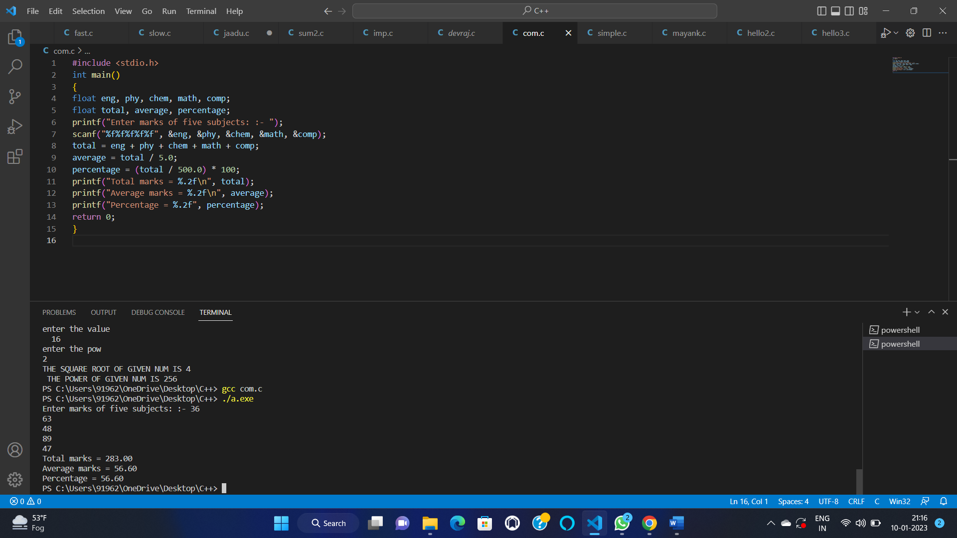

7–

#include <stdio.h>

#define BITS sizeof(int)

int main()

{

int num, msb;

printf("Enter any number: ");

scanf("%d", &num);

msb = 1 << (BITS - 1);

if(num & msb)

printf("MSB of %d is set (1).", num);

else

printf("MSB of %d is unset (0).", num);

return 0;

}

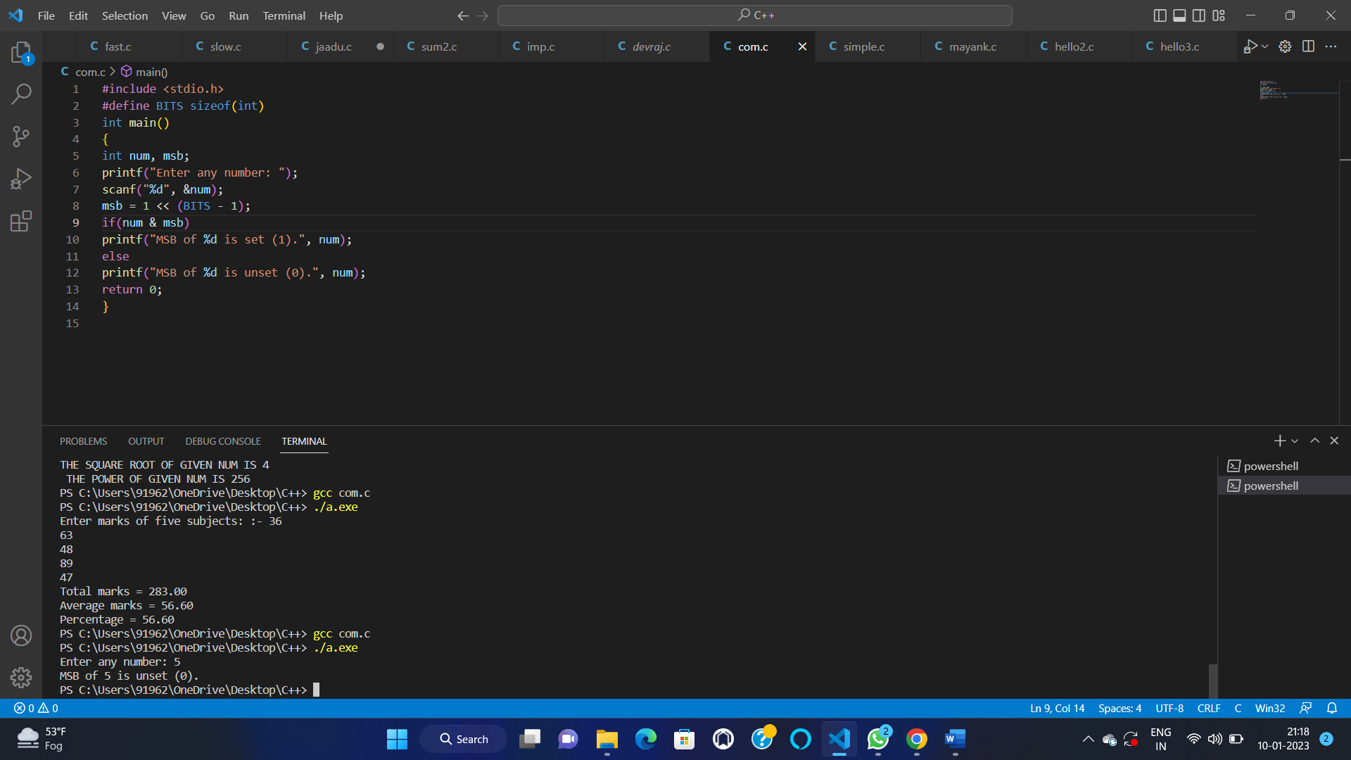

8–

#include <stdio.h>

int main()

{

int var1, var2, temp;

printf("Enter two integers ");

scanf("%d%d", &var1, &var2);

printf("Before SwappingnFirst variable = %d\nSecond variable = %d\n", var1, var2);

temp = var1;

var1 = var2;

var2 = temp;

printf("After SwappingnFirst variable = %d\nSecond variable = %d\n", var1, var2);

return 0;

}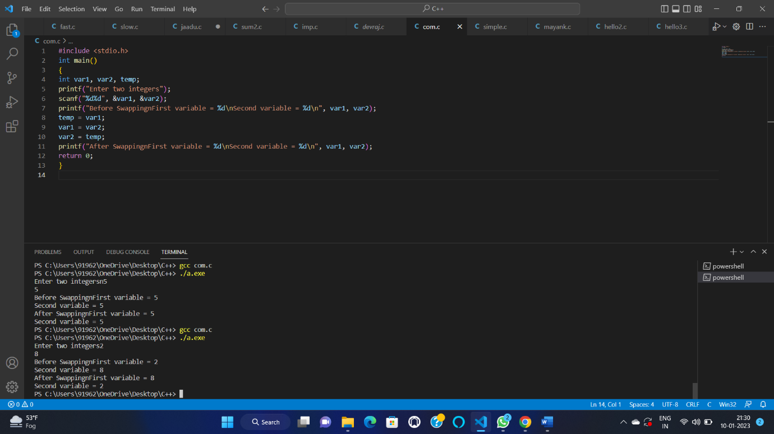

9—

#include<stdio.h>

int main() {

int a, b, c, max;

printf("Enter Three Integers\n");

scanf("%d %d %d", &a, &b, &c);

max = (a > b) ? ((a > c) ? a : c) : ((b > c) ? b : c);

printf("Maximum Number is = %d\n", max);

return 0;

}

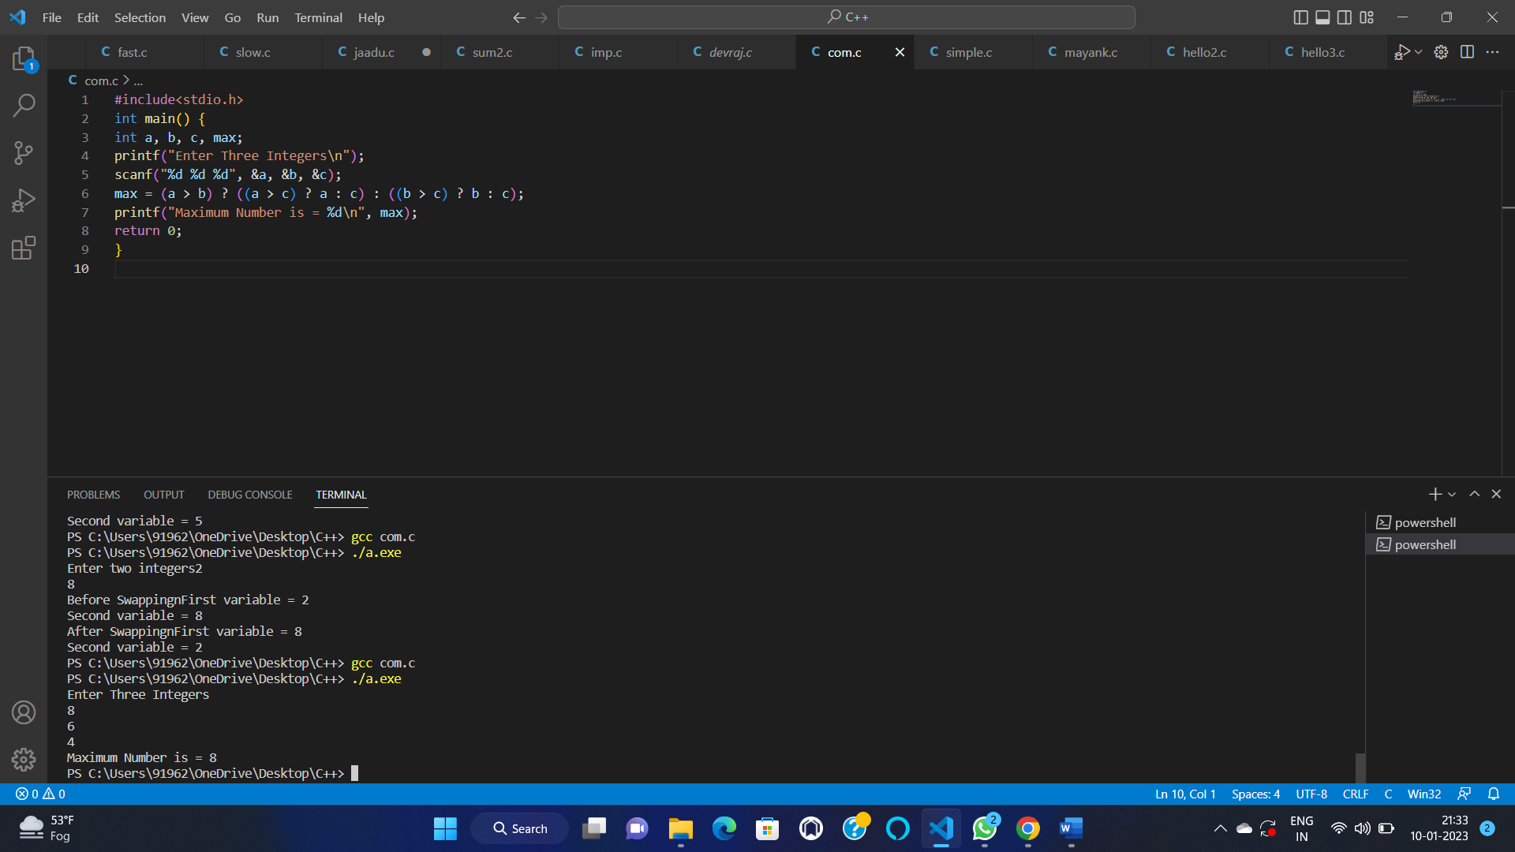—

10

#include <stdio.h>

int main()

{

char ch;

printf("Enter any character: ");

scanf("%c", &ch);

if((ch >= 'a' && ch <= 'z') || (ch >= 'A' && ch <= 'Z'))

{

printf("'%c' is alphabet.", ch);

}

else if(ch >= '0' && ch <= '9')

{

printf("'%c' is digit.", ch);

}

else

{

printf("'%c' is special character.", ch);

}

return 0;

}

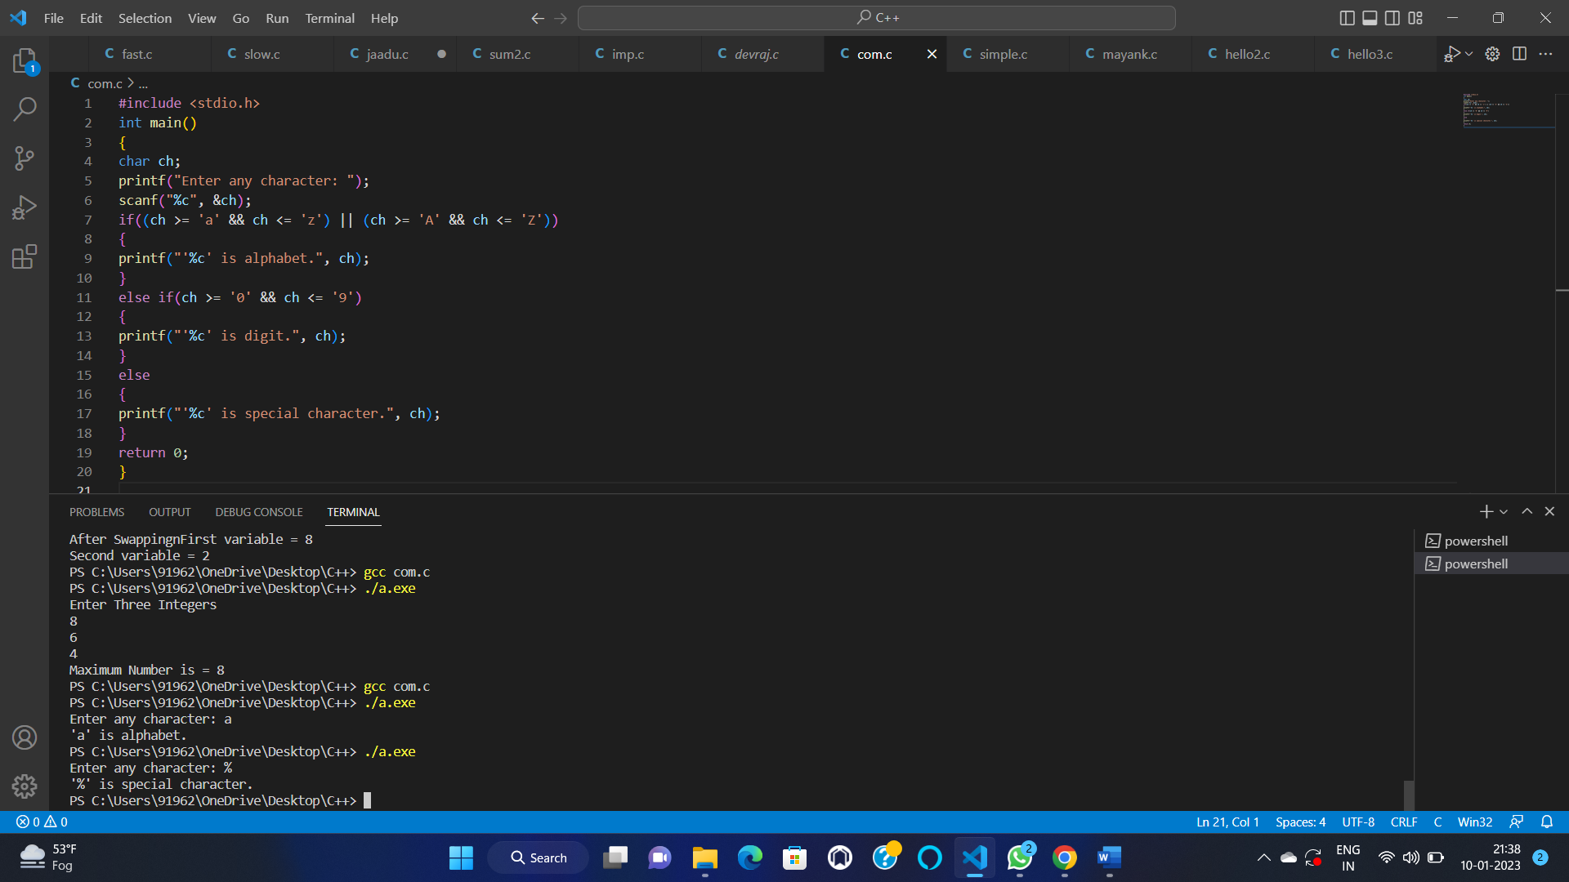

11—

#include <stdio.h>

int main()

{

int unit;

float amt, total_amt, sur_charge;

printf("Enter total units consumed: ");

scanf("%d", &unit);

if(unit <= 50)

{

amt = unit * 0.50;

}

else if(unit <= 150)

{

amt = 25 + ((unit-50) * 0.75);

}

else if(unit <= 250)

{

amt = 100 + ((unit-150) * 1.20);

}

else

{

amt = 220 + ((unit-250) * 1.50);

}

sur_charge = amt * 0.20;

total_amt = amt + sur_charge;

printf("Electricity Bill = Rs. %.2f", total_amt);

return 0;

}

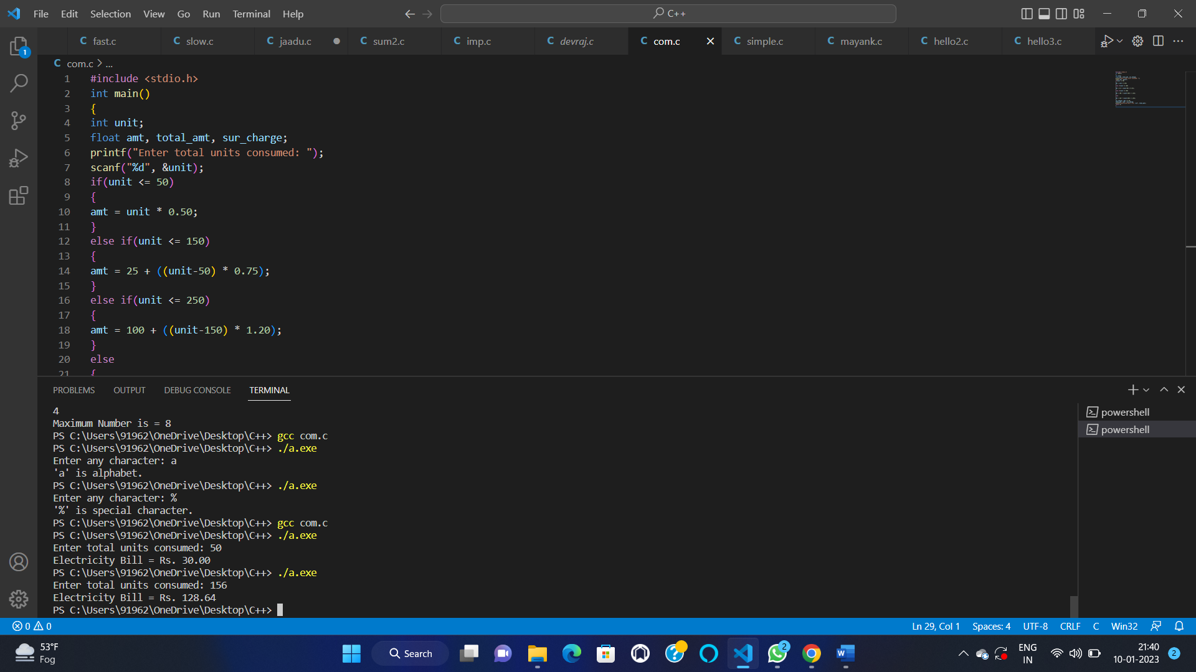

12–

#include<stdio.h>

int main()

{

int week;

printf("Enter week number(1-7): ");

scanf("%d", &week);

switch(week)

{

case 1:

printf("Monday");

break;

case 2:

printf("Tuesday");

break;

case 3:

printf("Wednesday");

break;

case 4:

printf("Thursday");

break;

case 5:

printf("Friday");

break;

case 6:

printf("Saturday");

break;

case 7:

printf("Sunday");

break;

default:

printf("Invalid input! Please enter week number between 1-7.");

}

return 0;

}

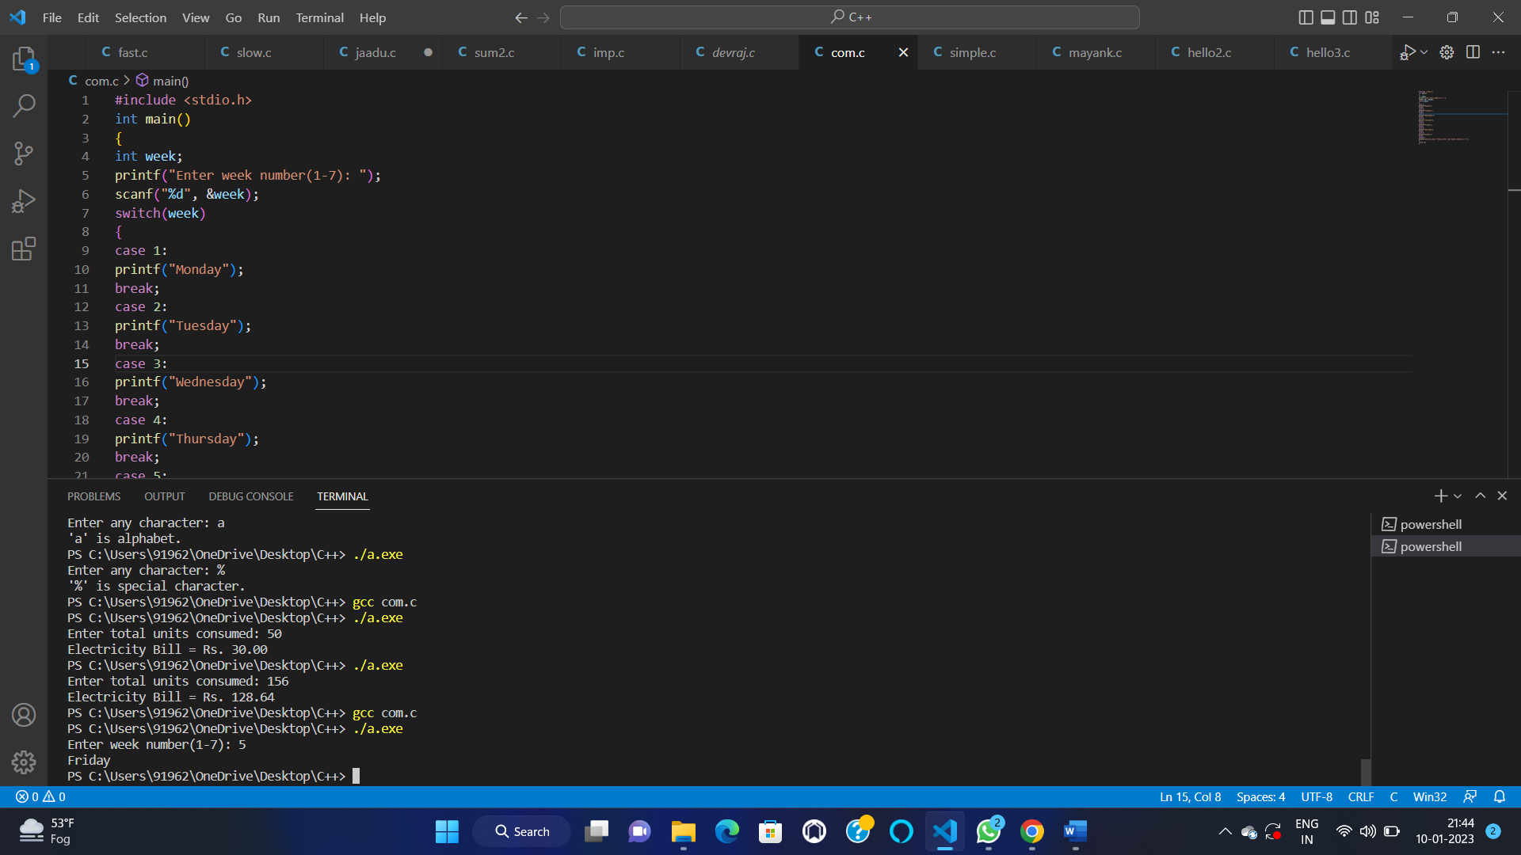

13–

#include <stdio.h>

int main()

{

char ch;

printf("Enter any alphabet: ");

scanf("%c", &ch);

switch(ch)

{

case 'a':

printf("Vowel");

break;

case 'e':

printf("Vowel");

break;

case 'i':

printf("Vowel");

break;

case 'o':

printf("Vowel");

break;

case 'u':

printf("Vowel");

break;

case 'A':

printf("Vowel");

break;

case 'E':

printf("Vowel");

break;

case 'I':

printf("Vowel");

break;

case 'O':

printf("Vowel");

break;

case 'U':

printf("Vowel");

break;

default:

printf("Consonant");

}

return 0;

}

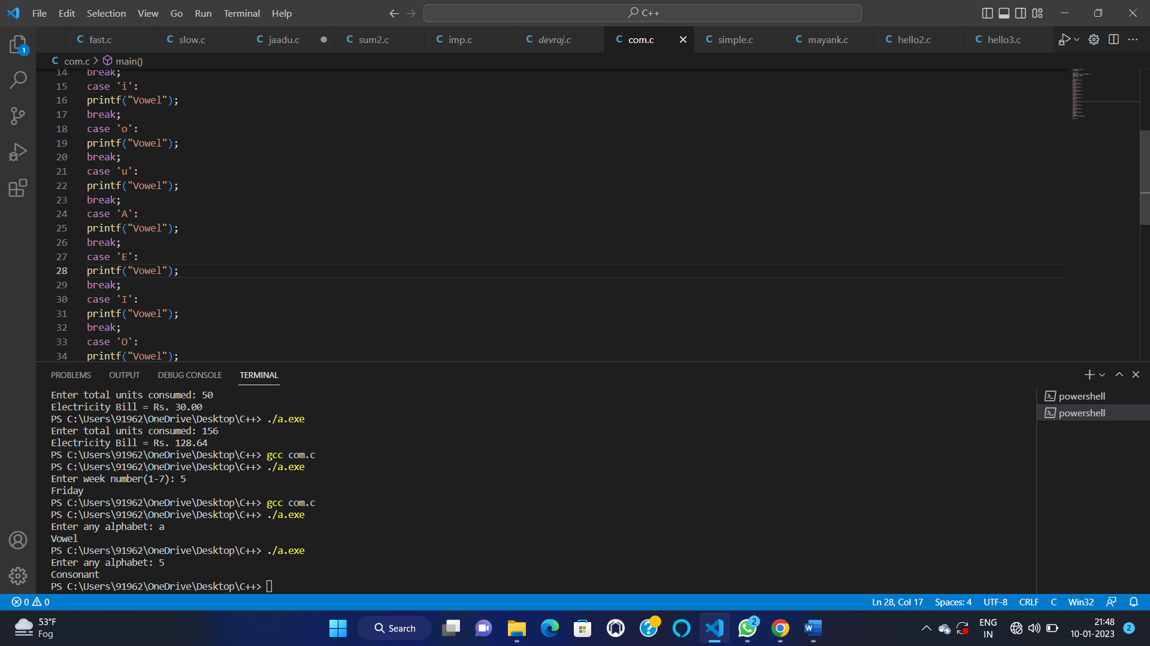

14—

#include <stdio.h>

int main()

{

int num;

printf("Enter any number: ");

scanf("%d", &num);

switch (num > 0)

{

case 1:

printf("%d is positive.", num);

break;

case 0:

switch (num < 0)

{

case 1:

printf("%d is negative.", num);

break;

case 0:

printf("%d is zero.", num);

break;

}

break;

}

return 0;

}

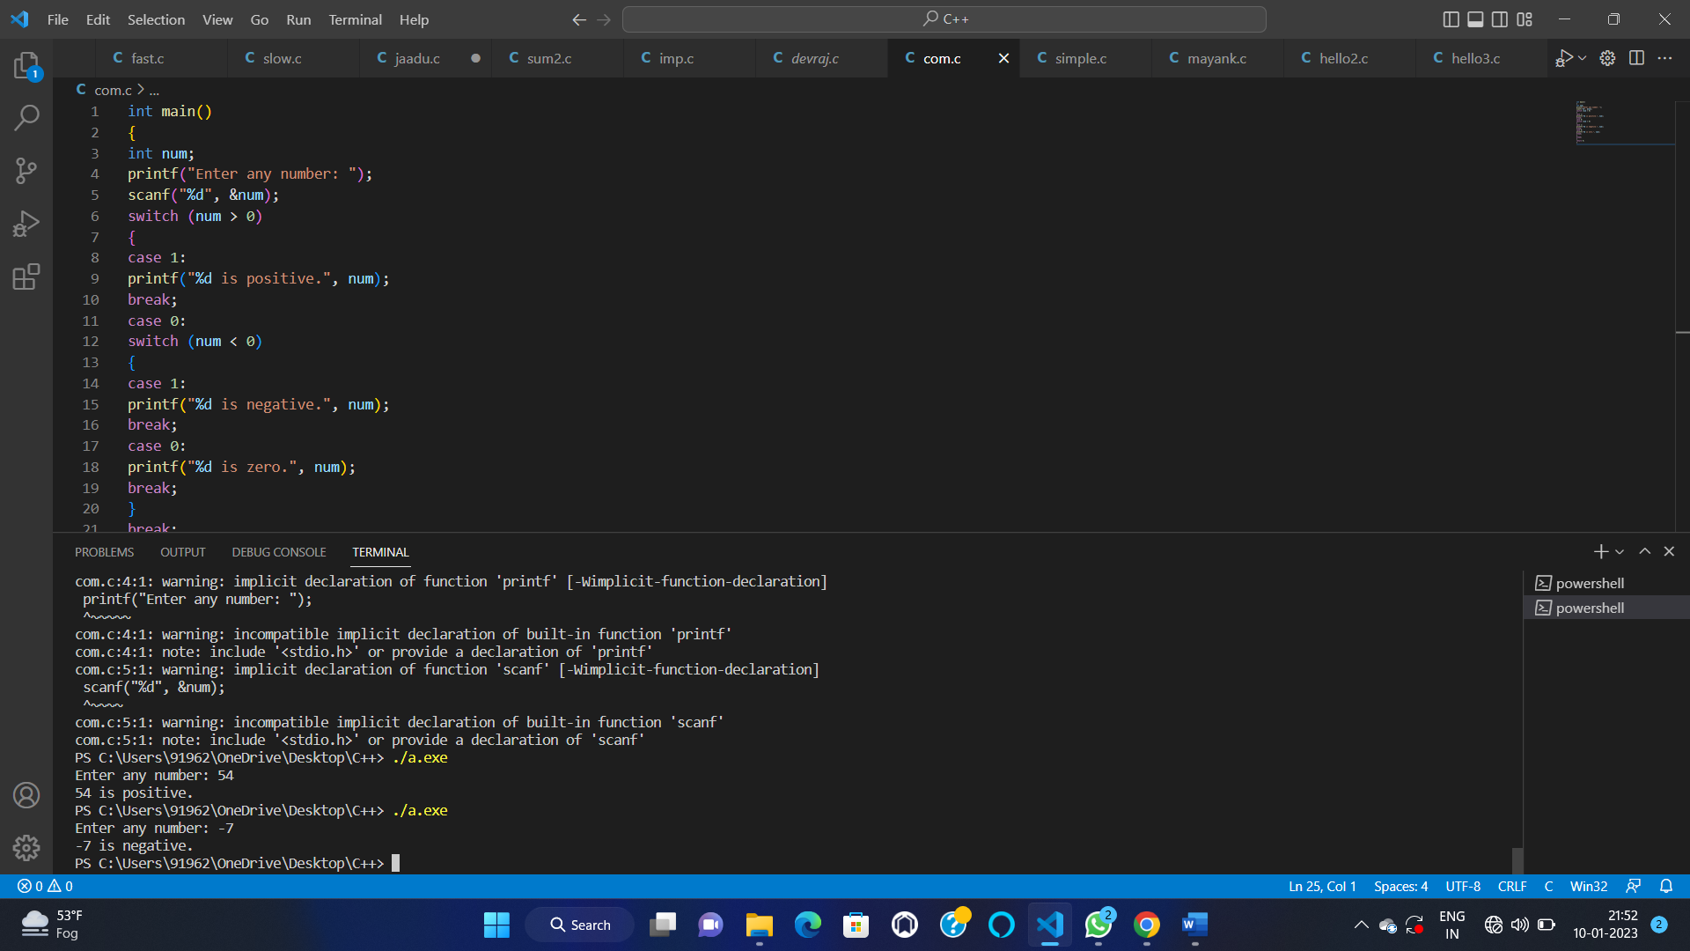

15–

#include<stdio.h>

int main(){

int side1, side2, side3;

printf("Enter sides of triangle:");

scanf("%d%d%d",&side1,&side2,&side3);

if(side1 == side2 && side2 == side3)

printf("Triangle is equilateral");

else if(side1 == side2 || side2 == side3 || side3 == side1)

printf("Triangle is isosceles");

else

printf("Triangle is scalene");

return 0;

}

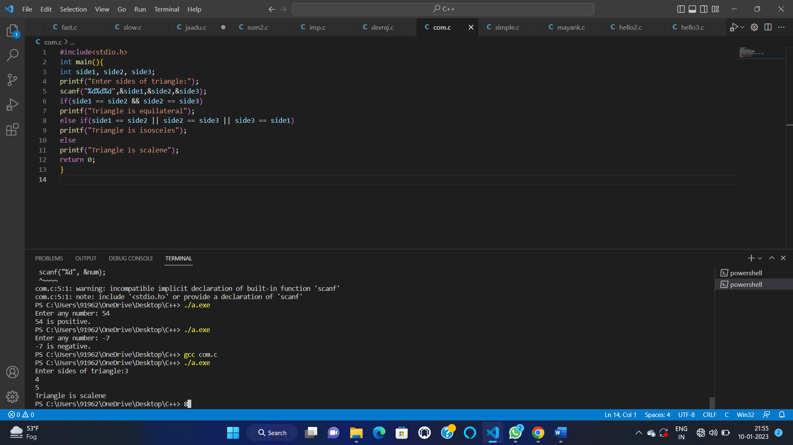

16—

#include <stdio.h>

int main()

{

int i, n, sum=0;

printf("Enter upper limit: ");

scanf("%d", &n);

for(i=1; i<=n; i++)

{

sum += i;

}

printf("Sum of first %d natural numbers = %d", n, sum);

return 0;

}

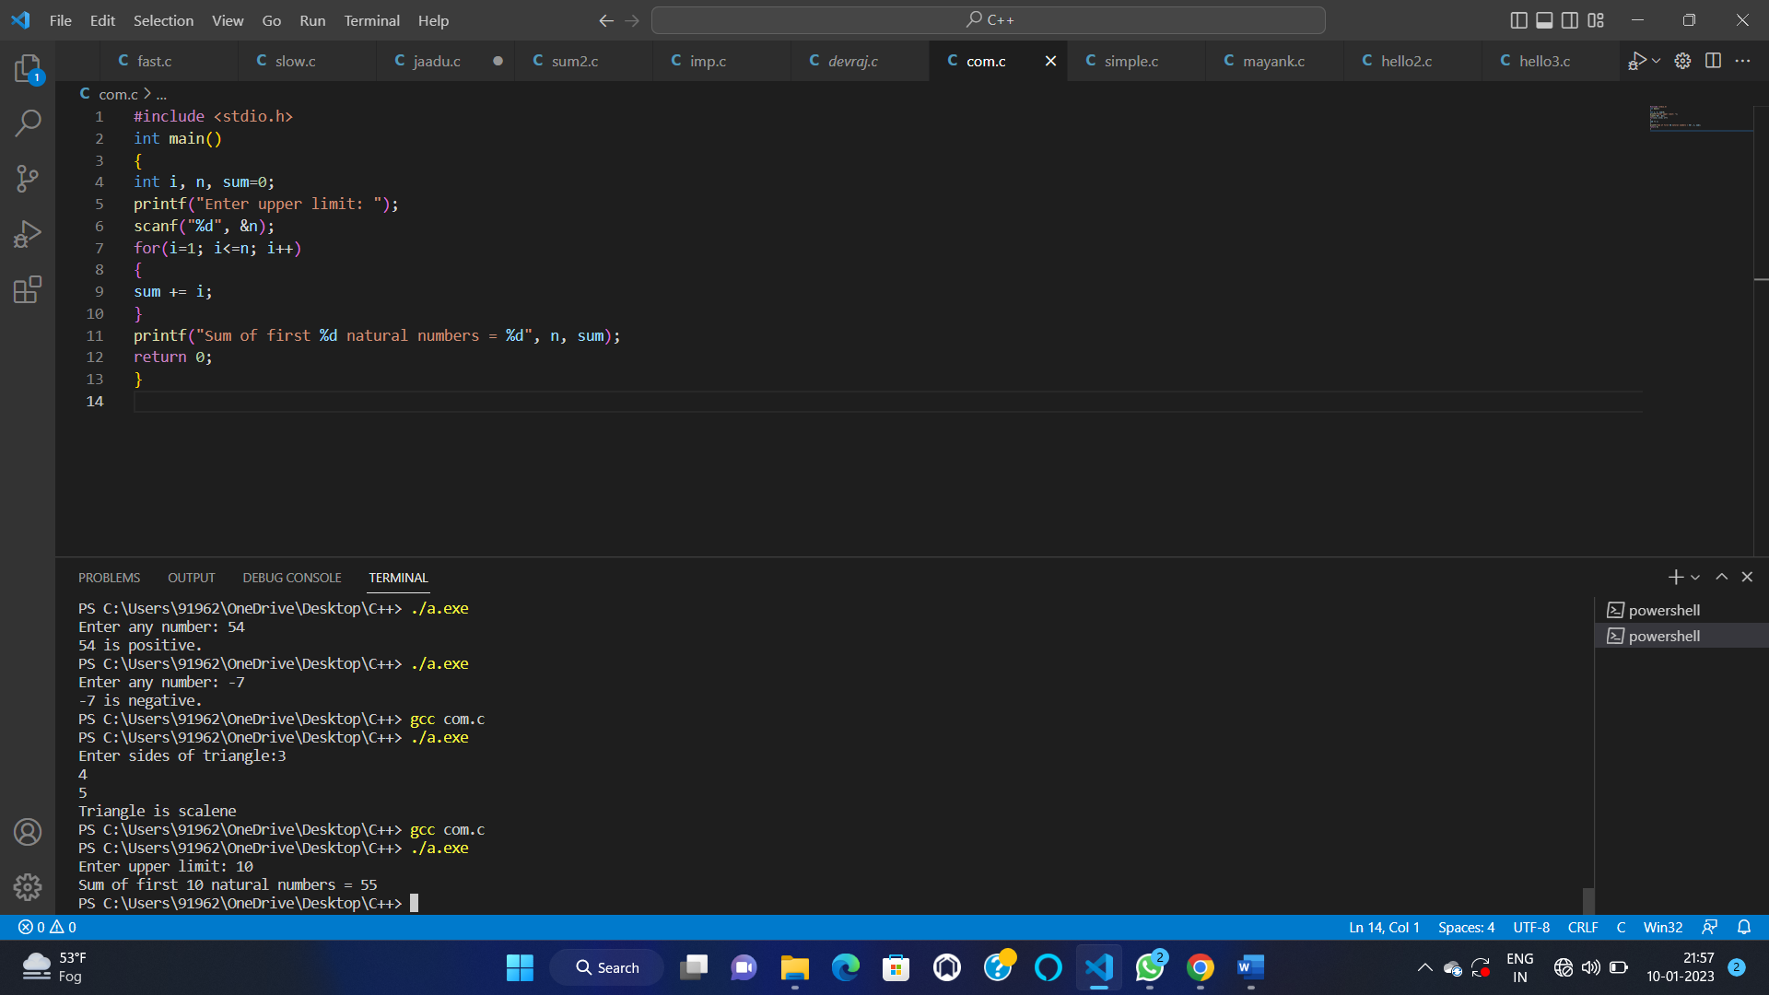

17—-

#include <stdio.h>

int main()

{

int i, n;

printf("Print all even numbers till: ");

scanf("%d", &n);

printf("Even numbers from 1 to n %d are: \n", n);

for(i=1; i<=n; i++)

{

if(i%2 == 0)

{

printf("%d\n", i);

}

}

return 0;

}

AND

#include <stdio.h>

int main()

{

int i, n, sum=0;

printf("Enter upper limit: ");

scanf("%d", &n);

for(i=2; i<=n; i+=2)

{

sum += i;

}

printf("Sum of all even number between 1 to n %d = %d", n, sum);

return 0;

}

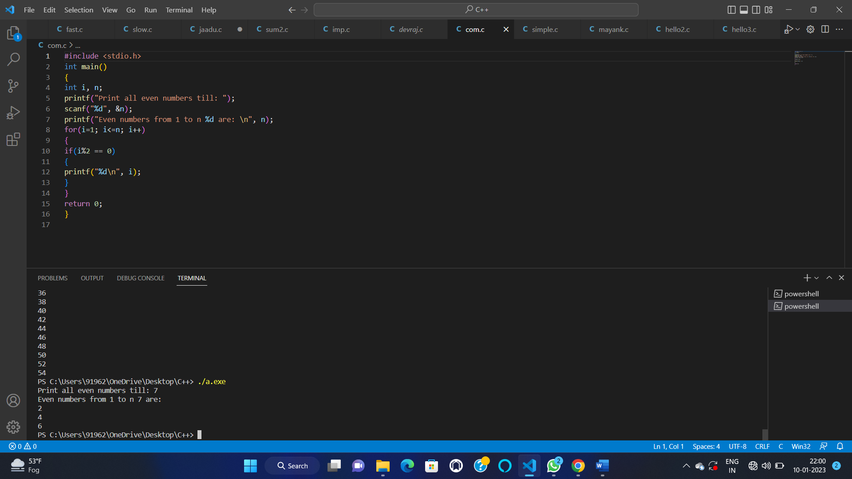

18—

#include <stdio.h>

int main()

{

int i, num;

printf("Enter number to print table: ");

scanf("%d", &num);

for(i=1; i<=10; i++)

{

printf("%d * %d = %d\n", num, i, (num*i));

}

return 0;

}

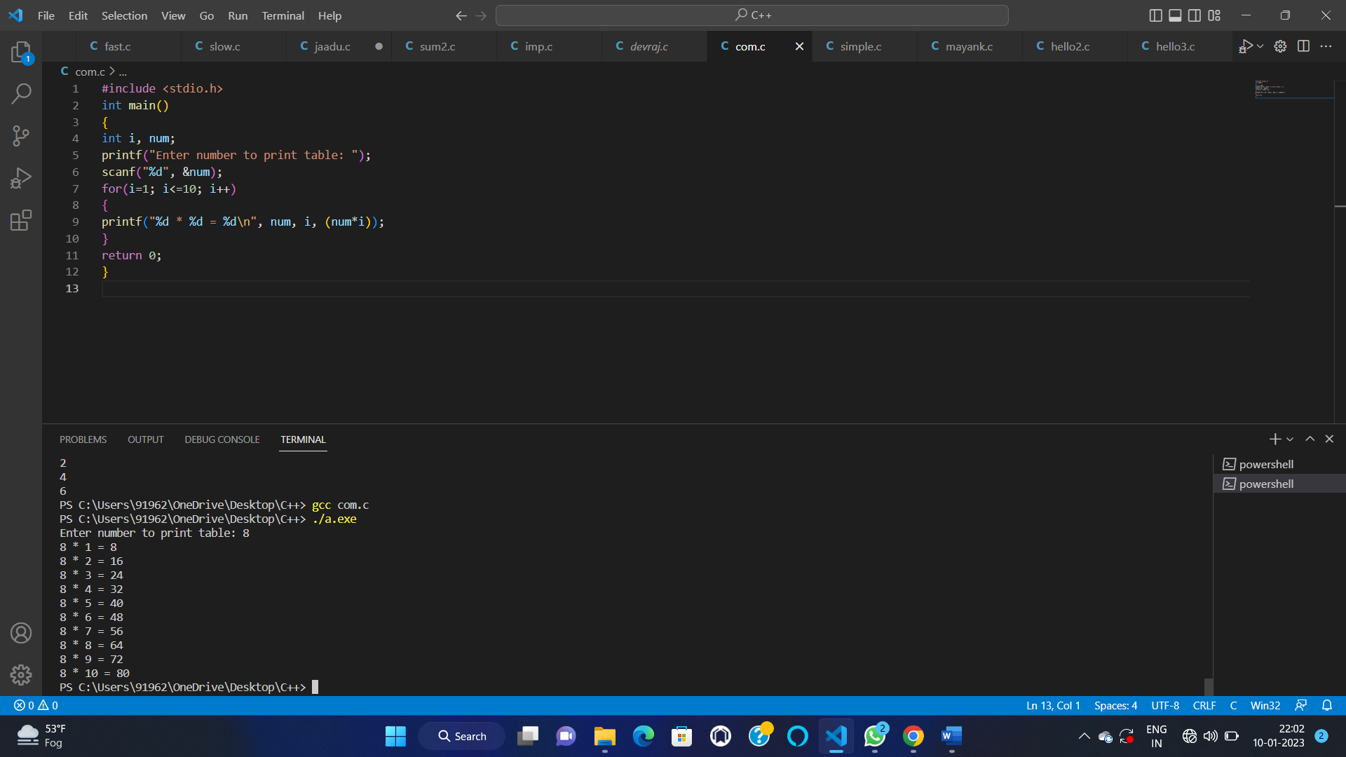

19—

#include<stdio.h>

int main(){

int x,fact=1,n;

printf("Enter a number to find factorial: ");

scanf("%d",&n);

for(x=1;x<=n;x++)

fact=fact*x;

printf("Factorial of %d is: %d",n,fact);

return 0;

}

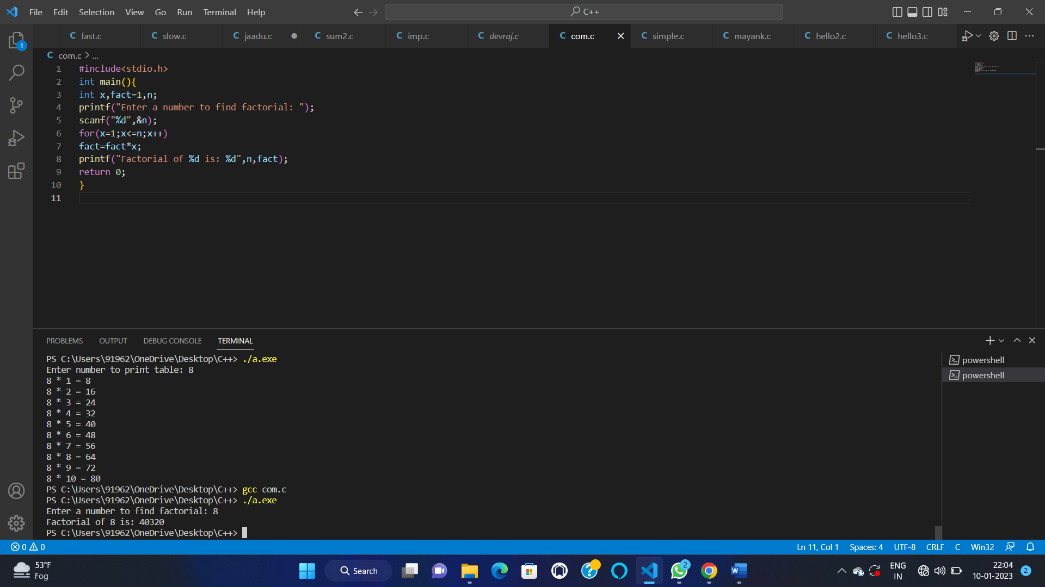

20—

#include <stdio.h>

int main() {

int n, reversed = 0, remainder, original;

printf("Enter an integer: ");

scanf("%d", &n);

original = n;

while (n != 0) {

remainder = n % 10;

reversed = reversed * 10 + remainder;

n /= 10;

}

if (original == reversed)

printf("%d is a palindrome.", original);

else

printf("%d is not a palindrome.", original);

return 0;

}

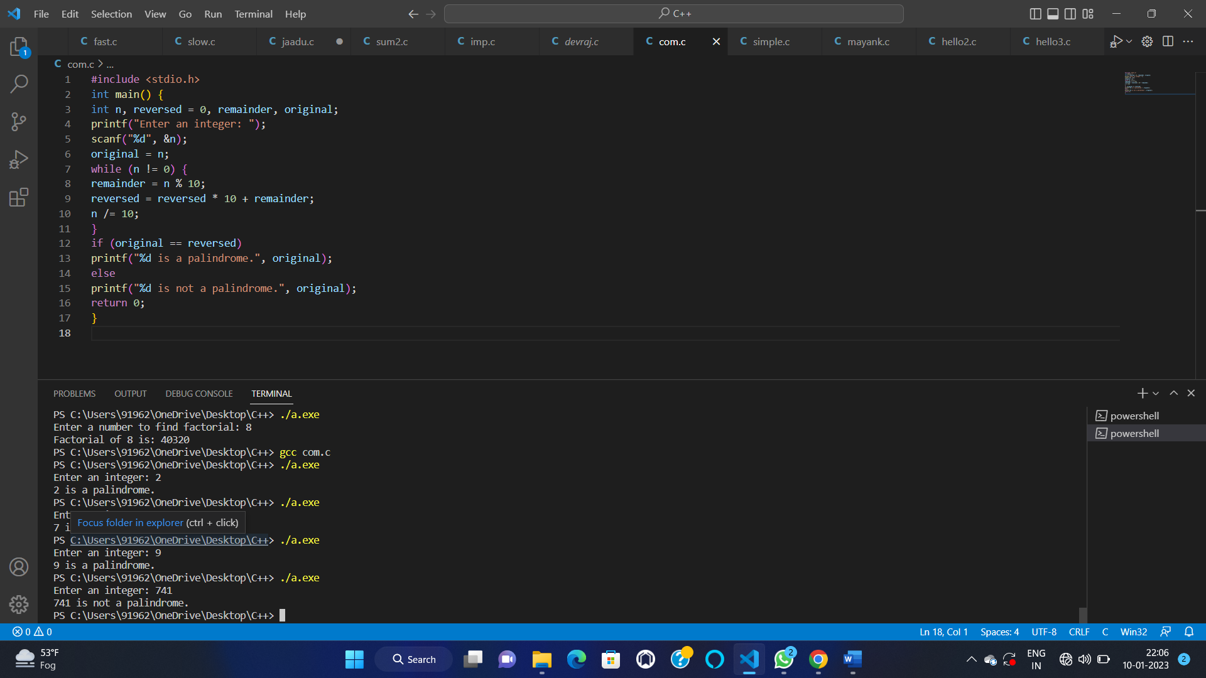

21–

#include <stdio.h>

#define BASE 10

int main()

{

long long num, n;

int i, lastDigit;

int freq[BASE];

printf("Enter any number: ");

scanf("%lld", &num);

for(i=0; i<BASE; i++)

{

freq[i] = 0;

}

n = num;

while(n != 0)

{

lastDigit = n %10;

n /= 10;

freq[lastDigit]++;

}

printf("Frequency of each digit in %lld is: \n", num);

for(i=0; i<BASE; i++)

{

printf("Frequency of %d = %d\n", i, freq[i]);

}

return 0;

}

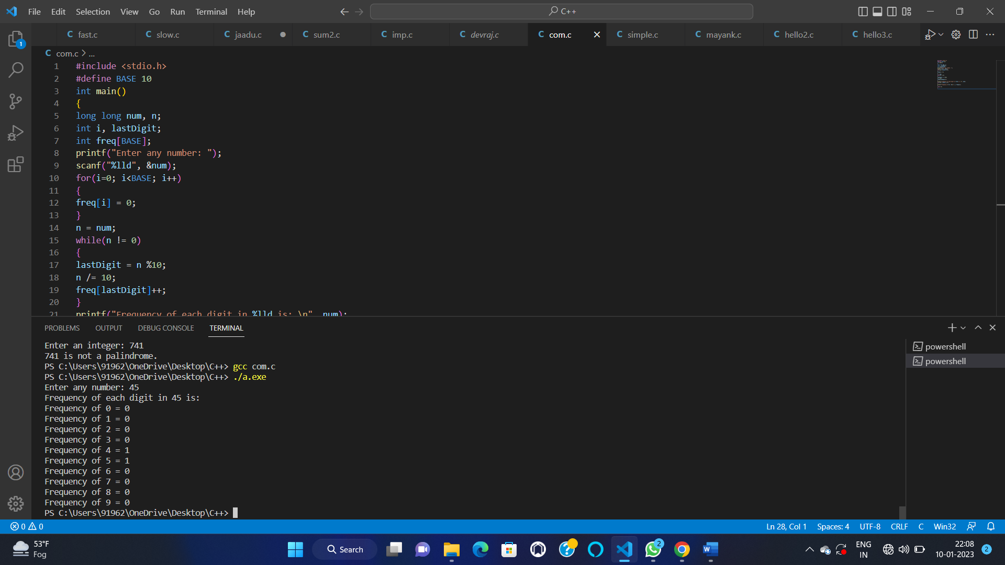

22—

#include <stdio.h>

int main() {

int a, b, x, y, t, gcd, lcm;

printf("Enter two integers\n");

scanf("%d%d", &x, &y);

a = x;

b = y;

while (b != 0) {

t = b;

b = a % b;

a = t;

}

gcd = a;

lcm = (x*y)/gcd;

printf("Greatest common divisor of %d and %d = %d\n", x, y, gcd);

printf("Least common multiple of %d and %d = %d\n", x, y, lcm);

return 0;

}

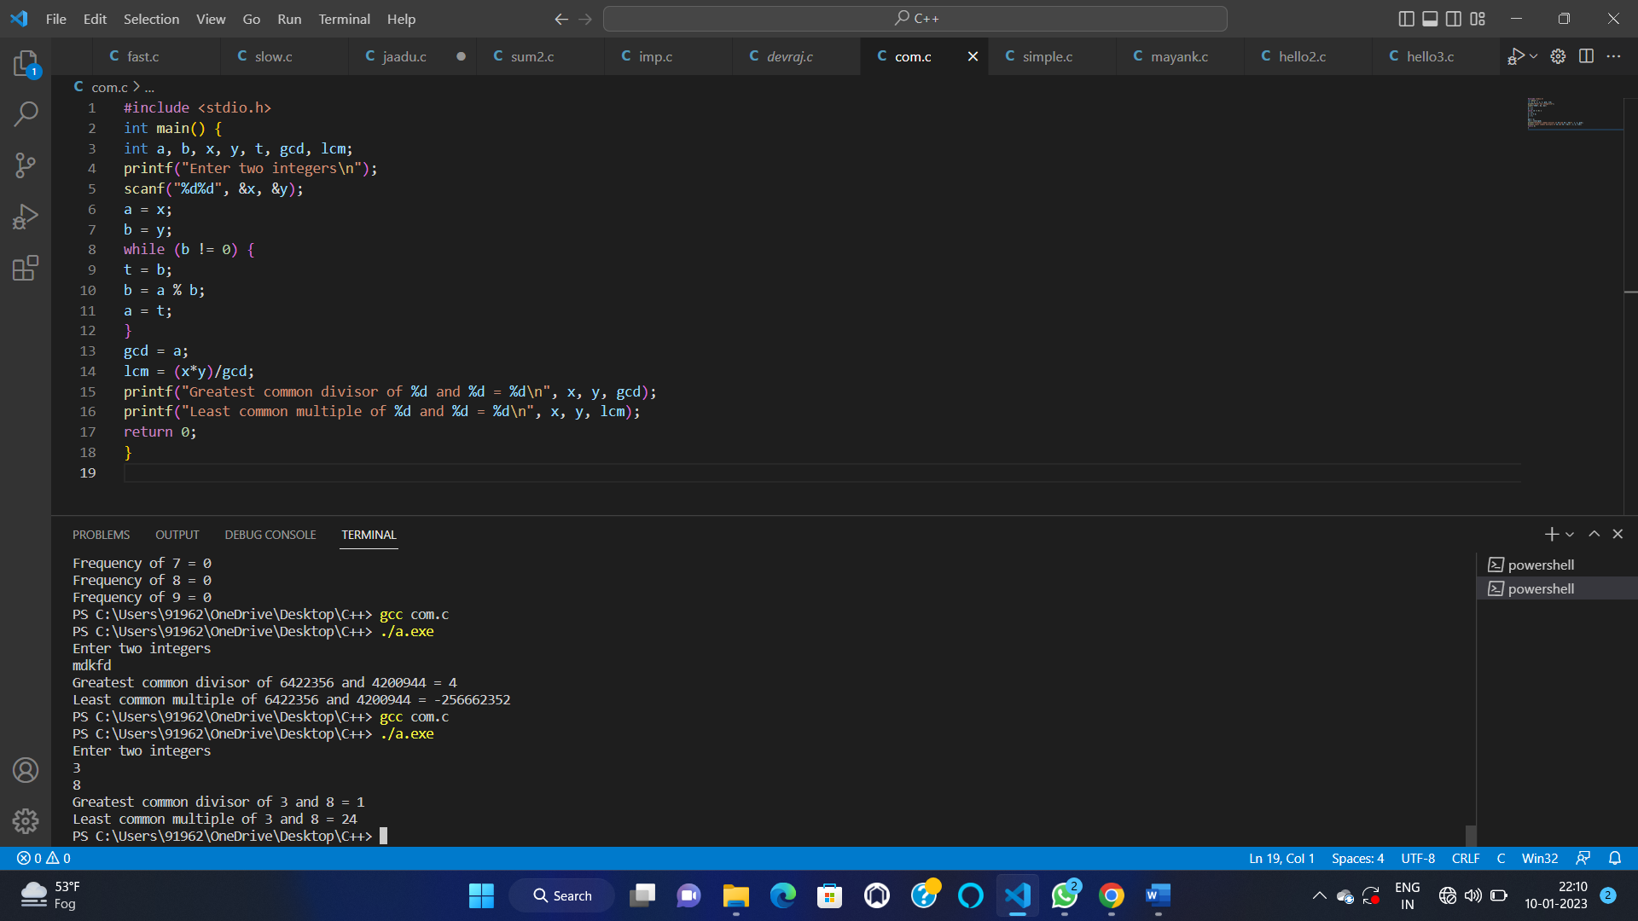

23—

#include<stdio.h>

int main(){

int num,i,count,n;

printf("Enter max range: ");

scanf("%d",&n);

for(num = 1;num<=n;num++){

count = 0;

for(i=2;i<=num/2;i++){

if(num%i==0){

count++;

break;

}

}

if(count==0 && num!= 1)

printf("%d ",num);

}

return 0;

}

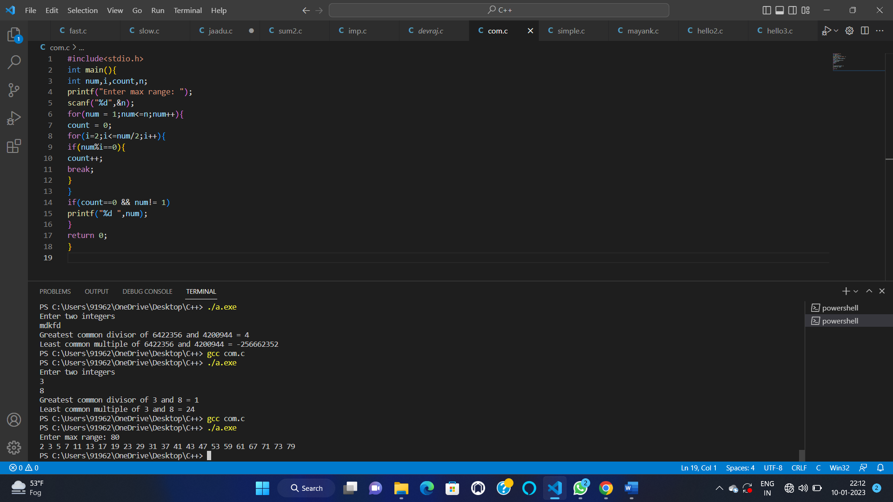

24—-

#include <stdio.h>

int main()

{

int n;

int sum=0;

printf("Enter a number");

scanf("%d",&n);

int k=n;

int r;

while(k!=0)

{

r=k%10;

int f=fact(r);

k=k/10;

sum=sum+f;

}

if(sum==n)

{

printf("\nNumber is a strong");

}

else

{

printf("\nNumber is not a strong");

}

return 0;

}

int fact(int r)

{

int mul=1;

for(int i=1;i<=r;i++)

{

mul=mul*i;

}

return mul;

}

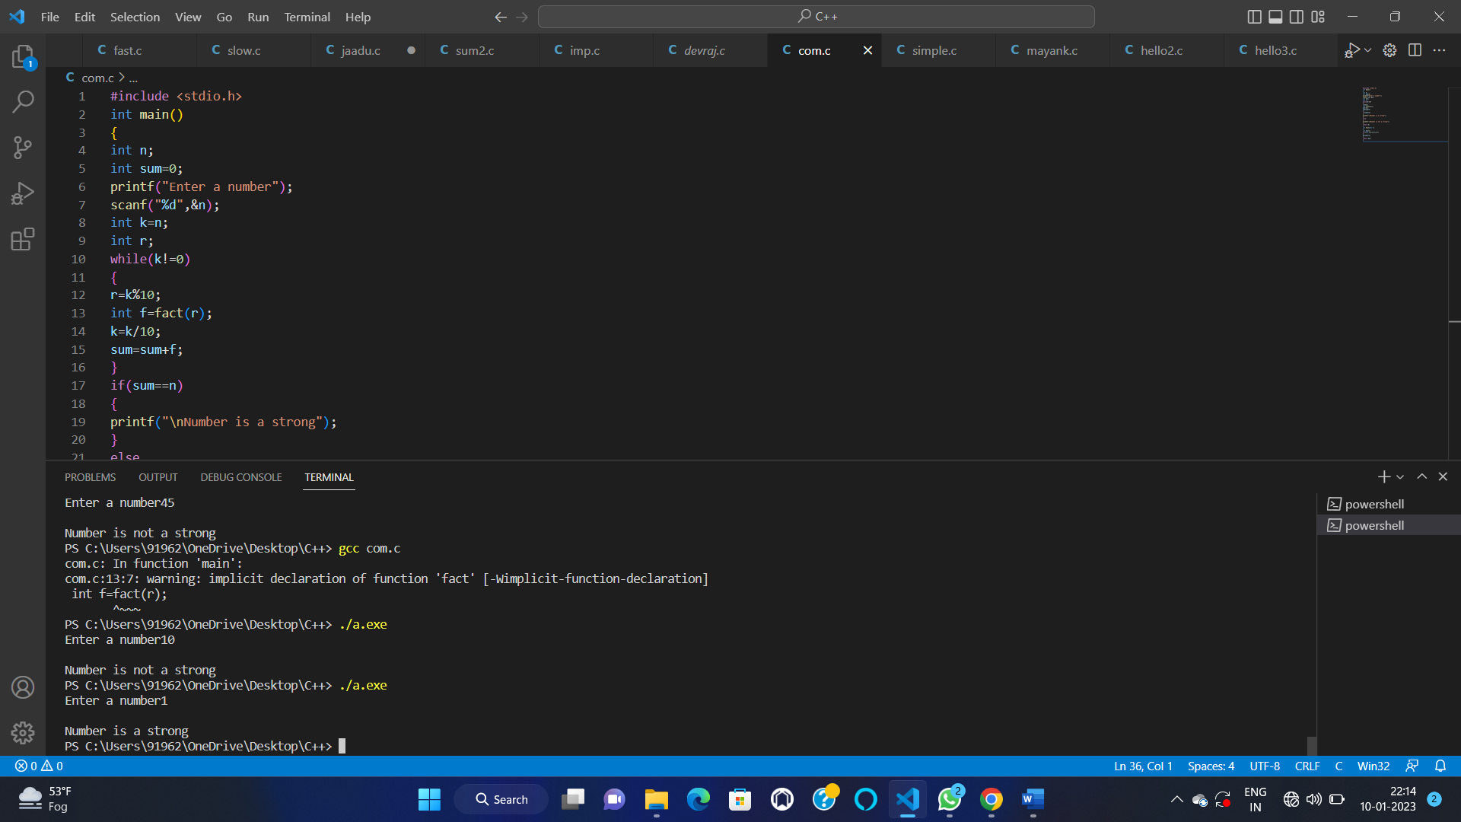

25—

#include<stdio.h>

int main()

{

int n1=0,n2=1,n3,i,number;

printf("Enter the number of elements:");

scanf("%d",&number);

printf("\n%d %d",n1,n2);

for(i=2;i<number;++i)

{

n3=n1+n2;

printf(" %d",n3);

n1=n2;

n2=n3;

}

return 0;

}

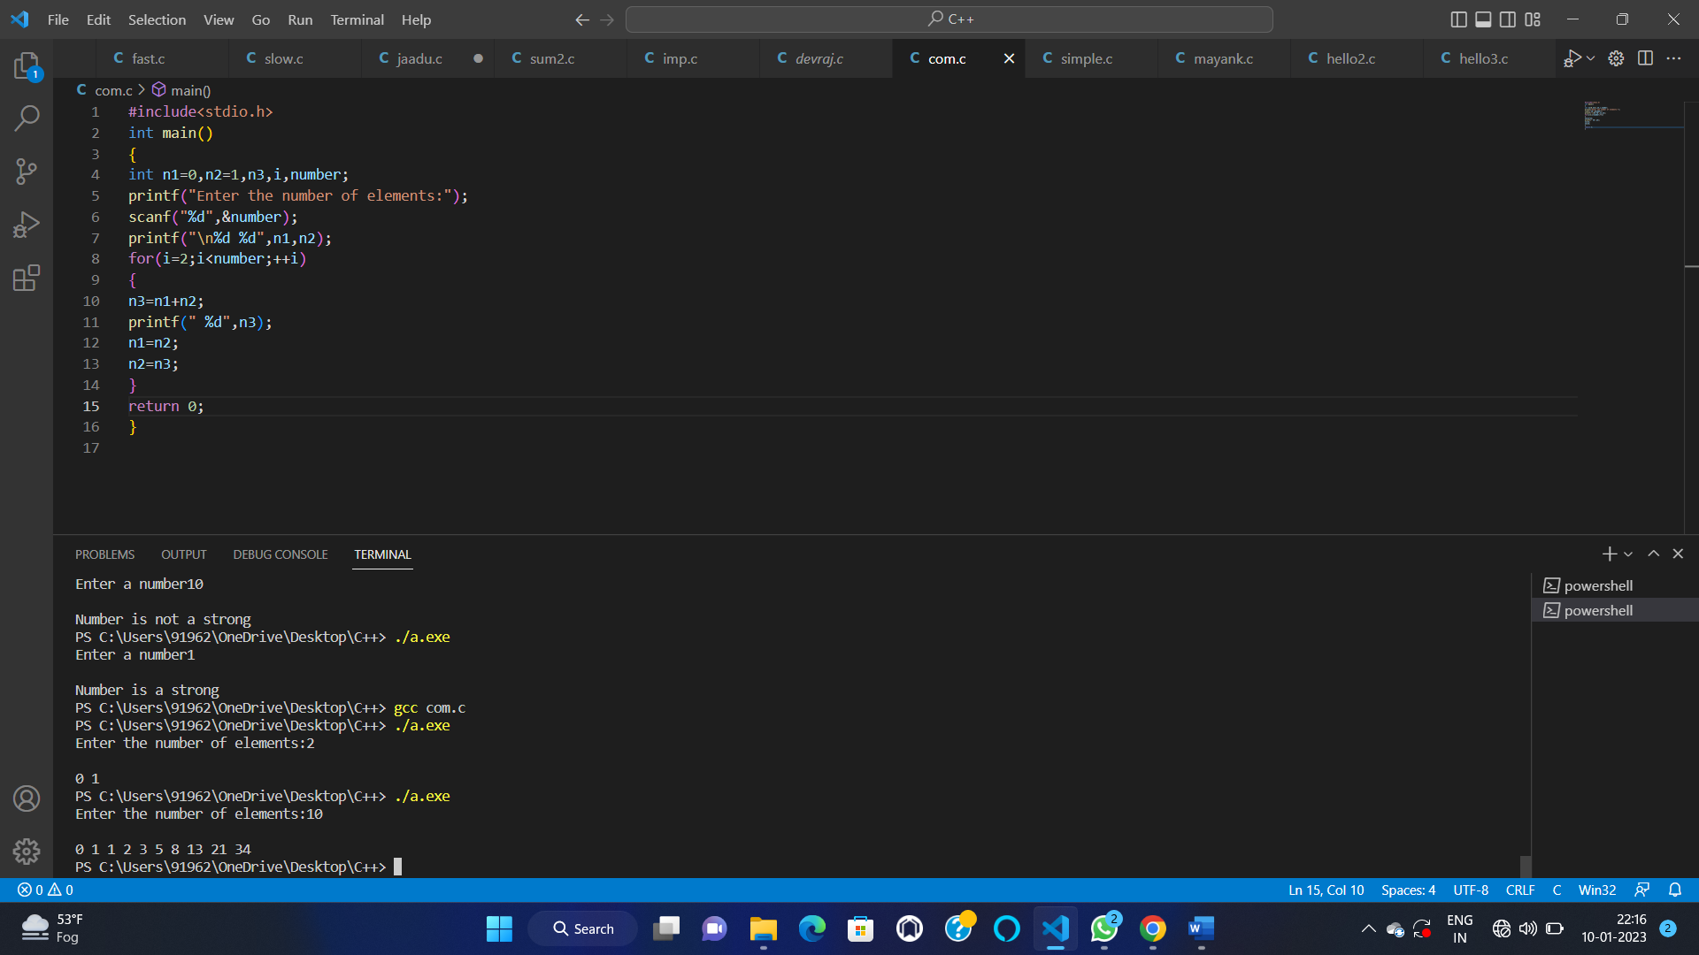

26—

#include<stdio.h>

int main()

{

int n,r,sum=0,temp;

printf("enter the number=");

scanf("%d",&n);

temp=n;

while(n>0)

{

r=n%10;

sum=sum+(r*r*r);

n=n/10;

}

if(temp==sum)

printf("armstrong number ");

else

printf("not armstrong number");

return 0;

}

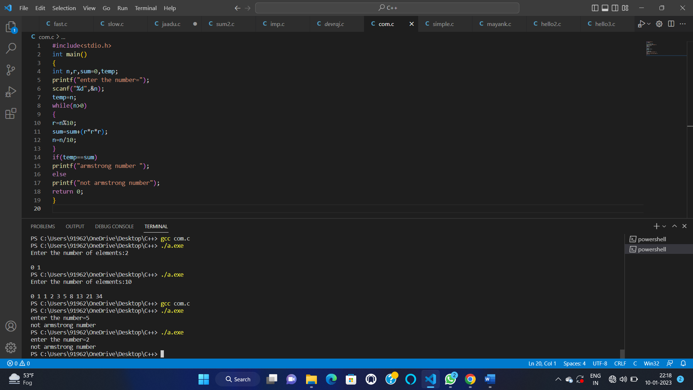

27—

#include<stdio.h>

#include<conio.h>

void main()

{

int num, rem, sum = 0, i;

printf("Enter a number\n");

scanf("%d", &num);

for(i = 1; i < num; i++)

{

rem = num % i;

if (rem == 0)

{

sum = sum + i;

}

}

if (sum == num)

printf(" it is a Perfect Number");

else

printf("\n it is not a Perfect Number");

getch();

}

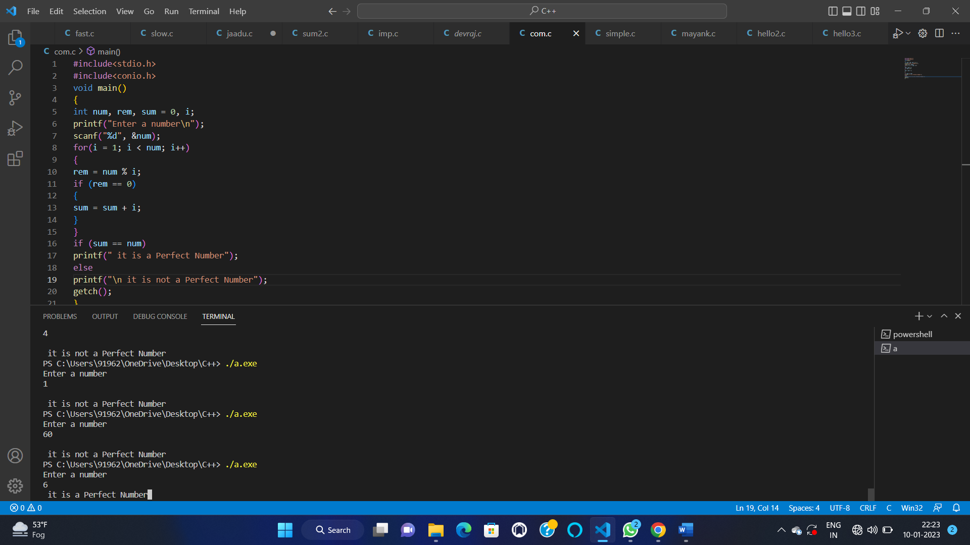

28—

#include <stdio.h>

int main()

{

int base, exponent;

long long power = 1;

int i;

printf("Enter base: ");

scanf("%d", &base);

printf("Enter exponent: ");

scanf("%d", &exponent);

for(i=1; i<=exponent; i++)

{

power = power * base;

}

printf("%d ^ %d = %lld", base, exponent, power);

return 0;

}

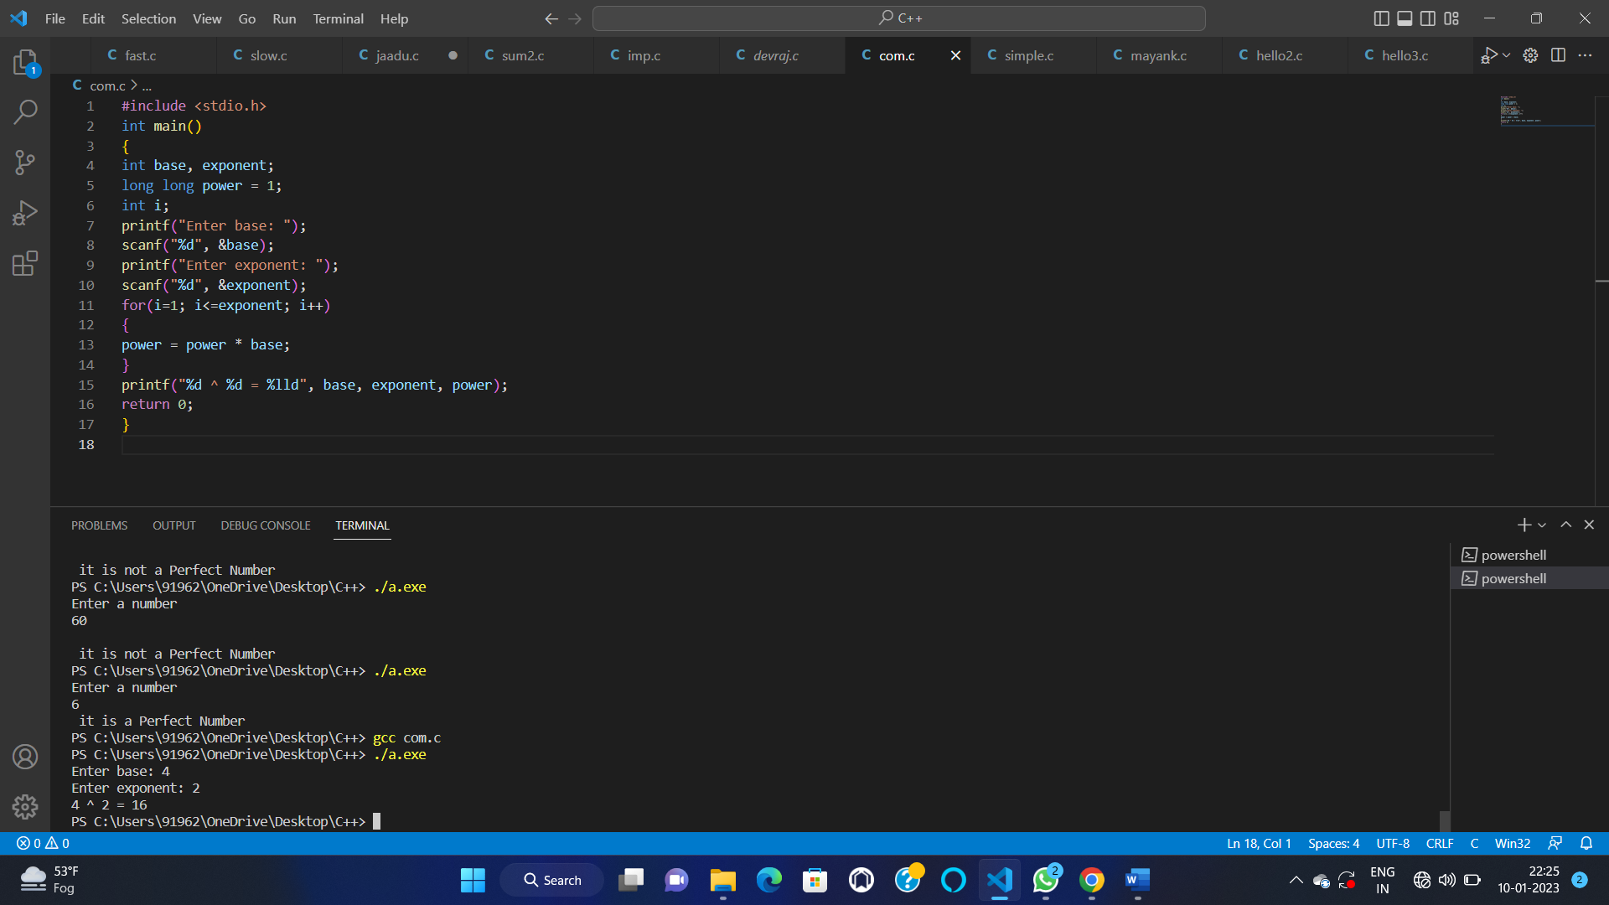

29—

#include <stdio.h>

int main() {

char c;

printf("Enter a character: ");

scanf("%c", &c);

printf("ASCII value of %c = %d", c, c);

return 0;

}

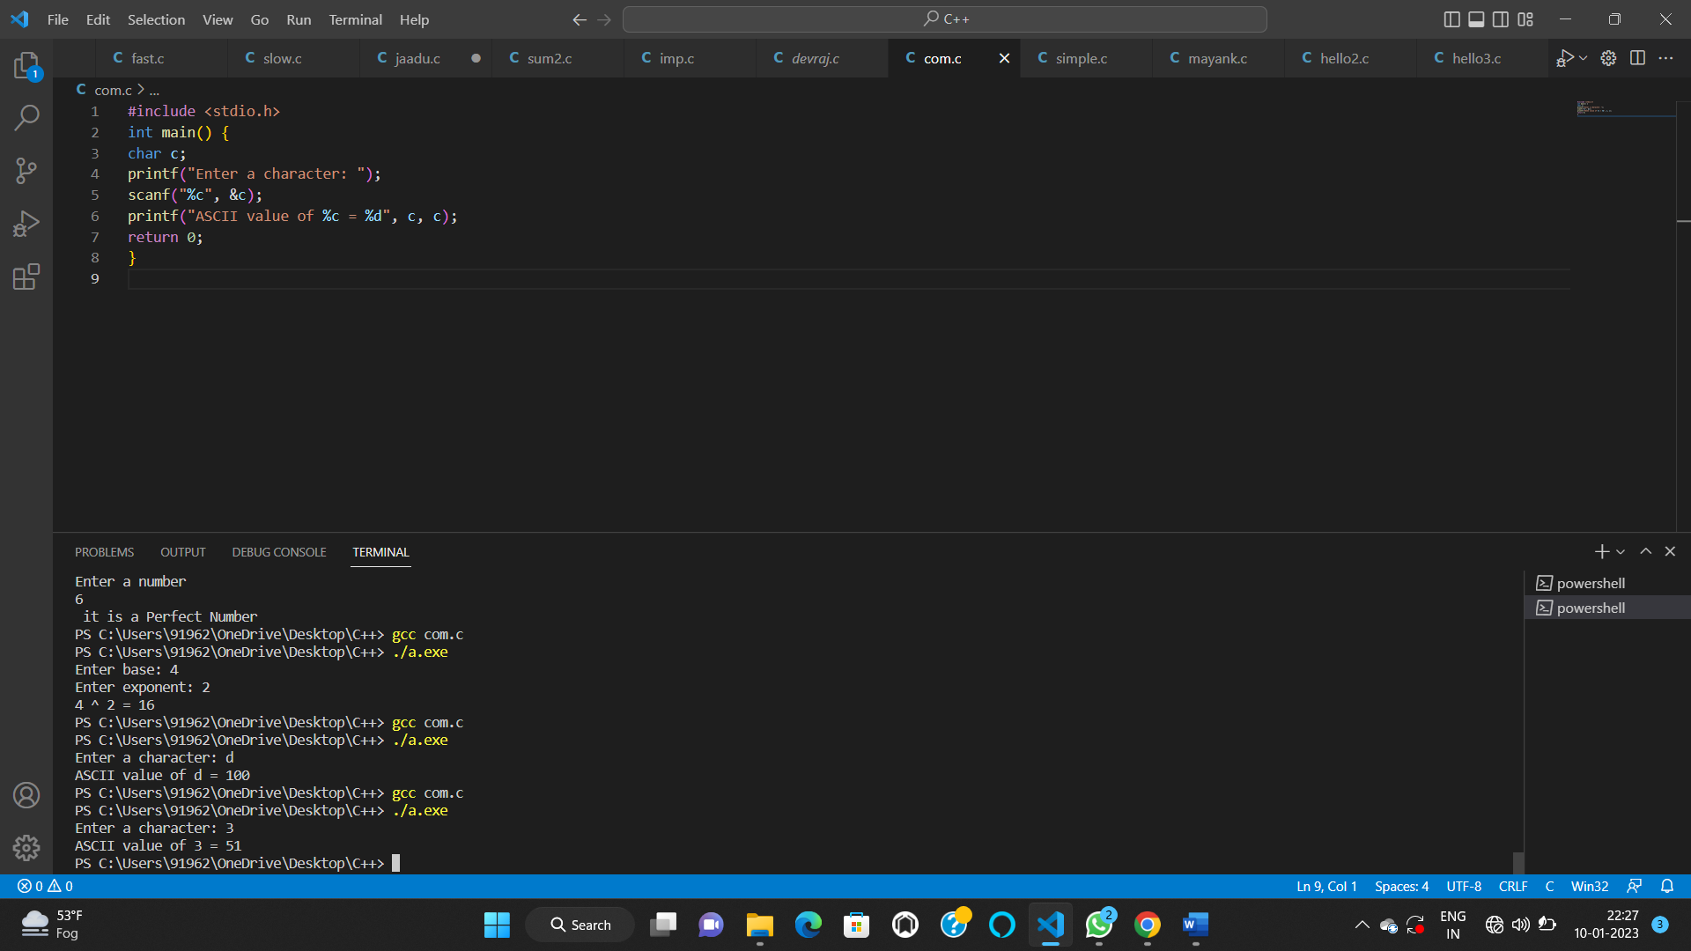

30—

#include <stdio.h>

int getFactorial(int n);

int main()

{

int row, rows, i, value;

printf("Enter Number of Rows:");

scanf("%d", &rows);

for(row = 0; row < rows; row++)

{

for(i = row; i <= rows; i++)

printf(" ");

for(i = 0; i <= row; i++)

{

value = getFactorial(row)/(getFactorial(i)*getFactorial(row-i));

printf("%4d", value);

}

printf("\n");

}

return 0;

}

int getFactorial(int N){

if(N < 0){

printf("Invalid Input: factorial not defined for \

negative numbers\n");

return 0;

}

int nFactorial = 1, counter;

for(counter = 1; counter <= N; counter++){

nFactorial = nFactorial * counter;

}

return nFactorial;

}

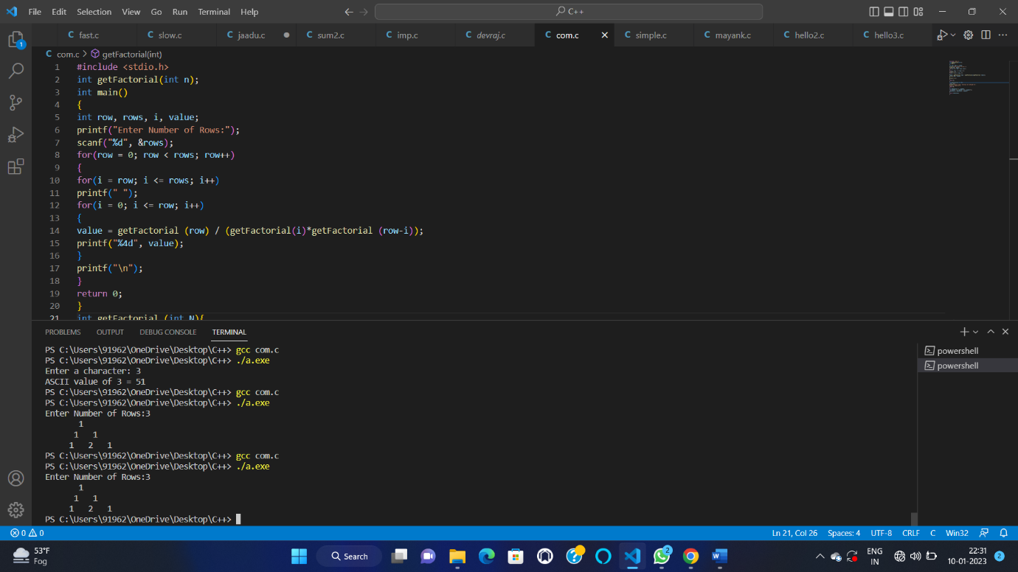

31—

#include<stdio.h>

int main()

{

int arr[100], size, i, sum = 0;

printf("Enter array size=");

scanf("%d",&size);

printf("Enter array elements=");

for(i = 0; i < size; i++)

scanf("%d",&arr[i]);

for(i = 0; i < size; i++) sum = sum + arr[i];

printf("Sum of the array = %d\n",sum);

return 0;

}

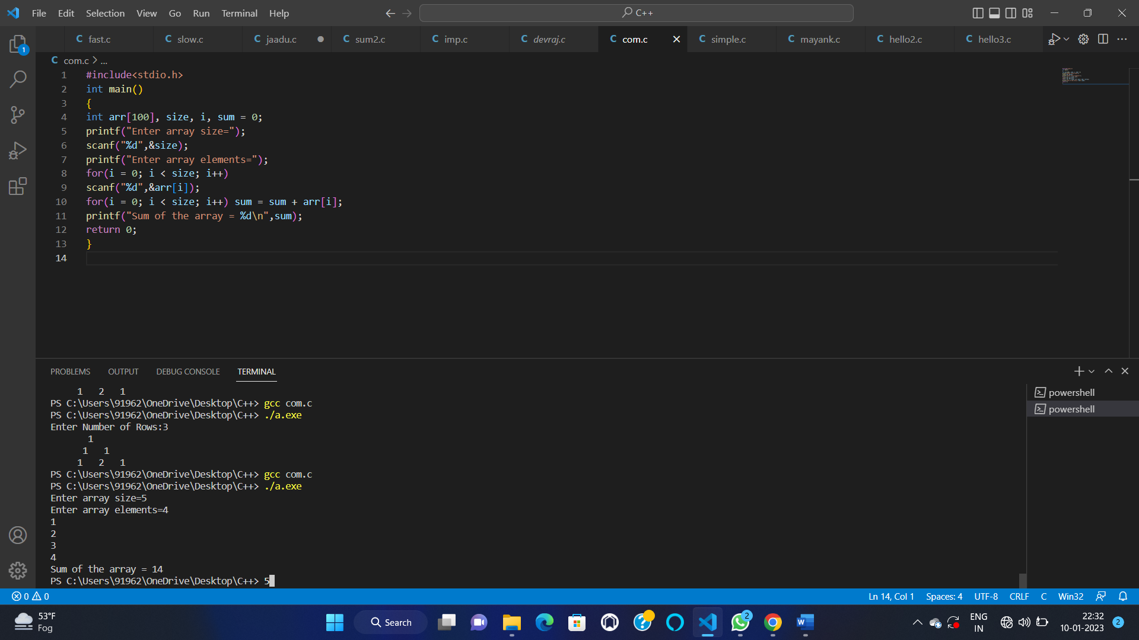

32—

#include<stdio.h>

int main()

{

int i, Size, a[20], b[20];

printf("\n Please Enter the Array Size \n");

scanf("%d", &Size);

printf("\n Please Enter the Array Elements \n");

for(i = 0; i < Size; i++)

{

scanf("%d", &a[i]);

}

for(i = 0; i < Size; i++)

{

b[i] = a[i];

}

printf("\n Elements of Second Array are: \n");

for(i = 0; i < Size; i++)

{

printf("\n Value Inside Array b[%d] = %d", i, b[i]);

}

return 0;;

}

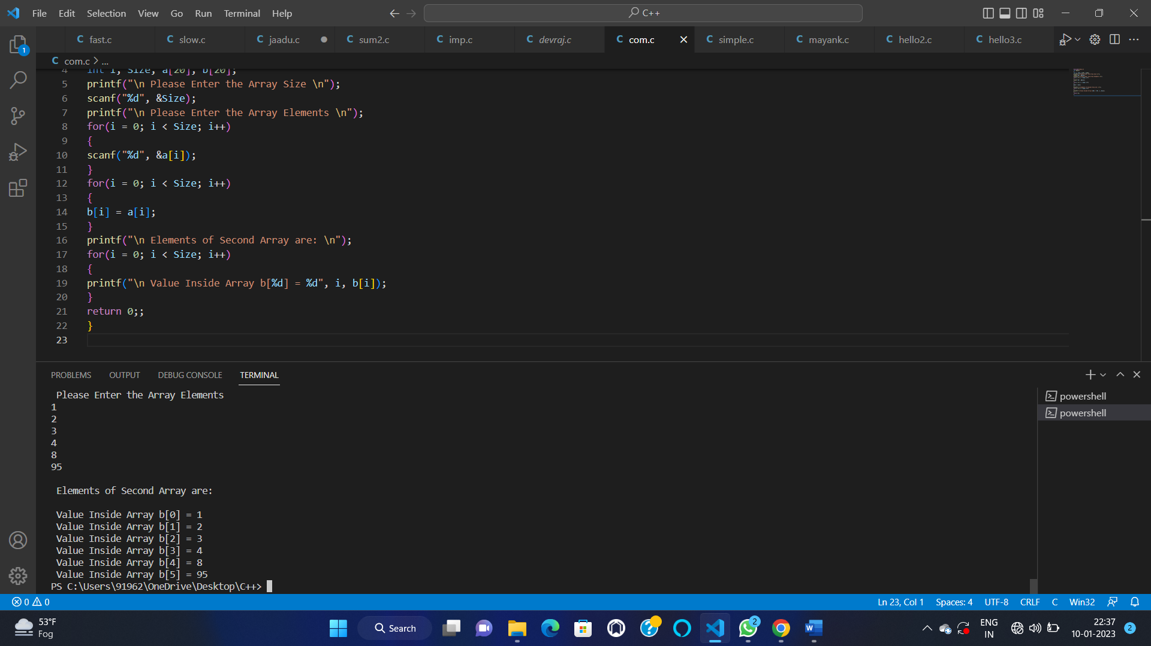

33—

#include <stdio.h>

int main()

{

int arr[100] = { 0 };

int i, x, pos, n = 10;

for (i = 0; i < 10; i++)

arr[i] = i + 1;

for (i = 0; i < n; i++)

printf("%d ", arr[i]);

printf("\n");

x = 50;

pos = 5;

n++;

for (i = n - 1; i >= pos; i--)

arr[i] = arr[i - 1];

arr[pos - 1] = x;

for (i = 0; i < n; i++)

printf("%d ", arr[i]);

printf("\n");

return 0;

}

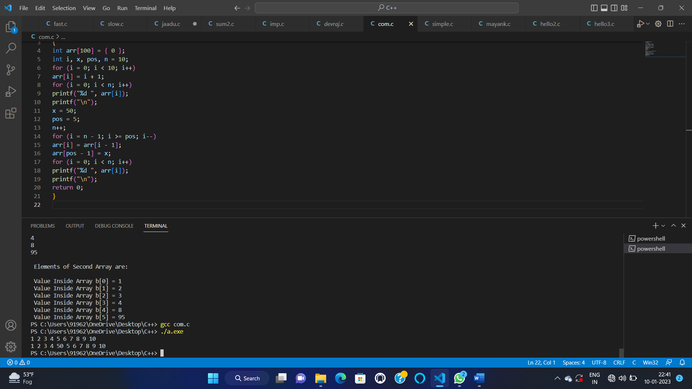

34—

#include <stdio.h>

#define MAX_SIZE 100

int main()

{

int arr[MAX_SIZE];

int i, size, pos;

printf("Enter size of the array : ");

scanf("%d", &size);

printf("Enter elements in array : ");

for(i=0; i<size; i++)

{

scanf("%d", &arr[i]);

}

printf("Enter the element position to delete : ");

scanf("%d", &pos);

if(pos < 0 || pos > size)

{

printf("Invalid position! Please enter position between 1 to %d", size);

}

else

{

for(i=pos-1; i<size-1; i++)

{

arr[i] = arr[i + 1];

}

size--;

printf("\nElements of array after delete are : ");

for(i=0; i<size; i++)

{

printf("%d\t", arr[i]);

}

}

return 0;

}

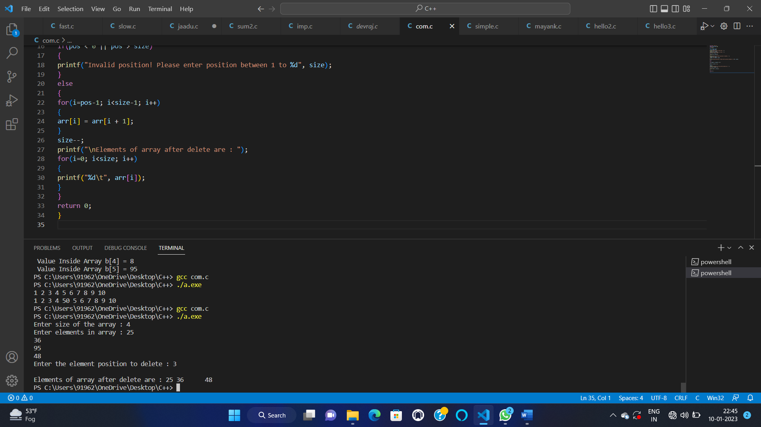

35—

#include <stdio.h>

int main()

{

int array[100], search, c, number;

printf("Enter the number of elements in array\n");

scanf("%d",&number);

printf("Enter %d numbers\n", number);

for ( c = 0 ; c < number ; c++ )

scanf("%d",&array[c]);

printf("Enter the number to search\n");

scanf("%d",&search);

for ( c = 0 ; c < number ; c++ )

{

if ( array[c] == search ) /* if required element found */

{

printf("%d is present at location %d.\n", search, c+1);

break;

}

}

if ( c == number )

printf("%d is not present in array.\n", search);

return 0;

}

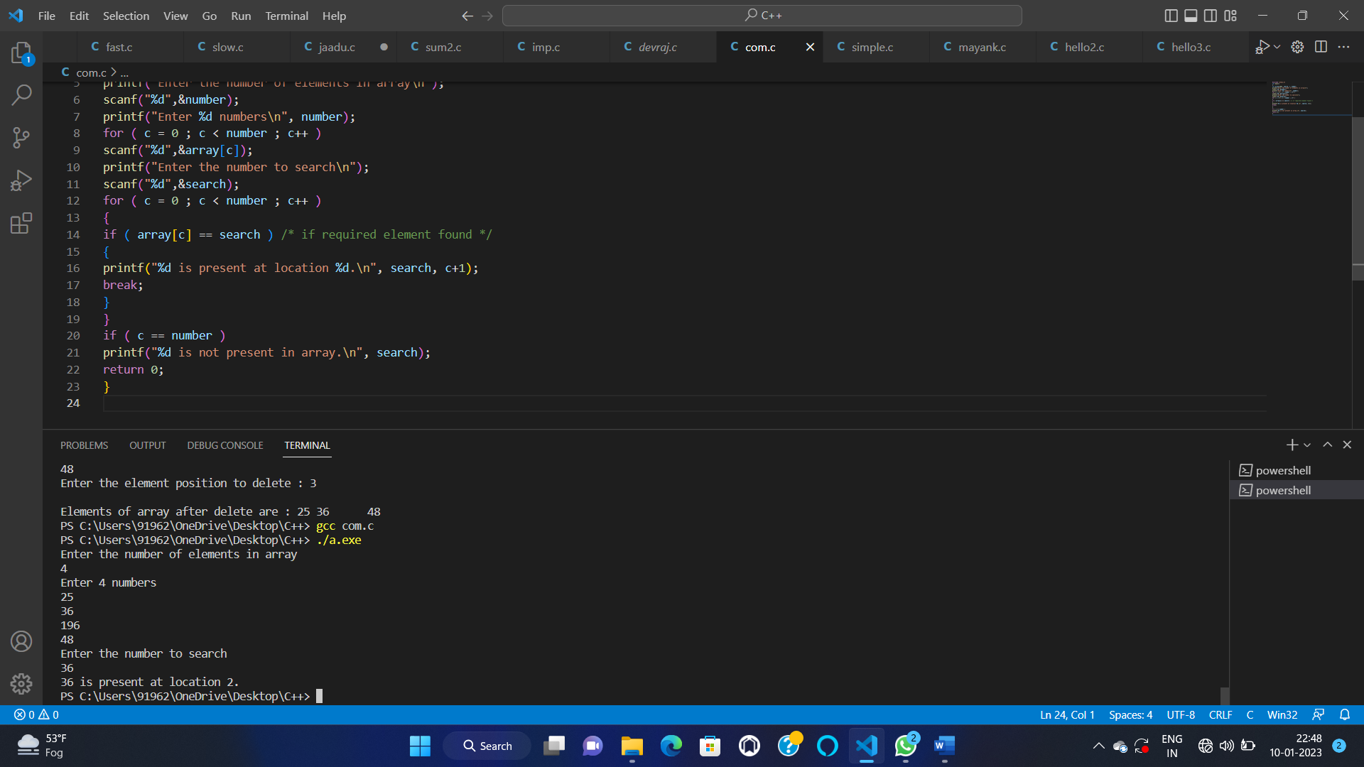

36—

#include <stdio.h>

void main()

{

int a[100],i,j,n,temp;

printf ("Enter the number of elements:");

scanf ("%d",&n);

printf("Enter the values:");

for (i=0;i<n;i++){

scanf("%d",&a[i]);

}

for(i=0;i<n;i++)

{

for(j=i+1;j<n;j++)

{

if(a[i]>a[j])

{

temp = a[i];

a[i]=a[j];

a[j]=temp;

}

}

}

printf("Second largest element:%d",a[n-2]);

}

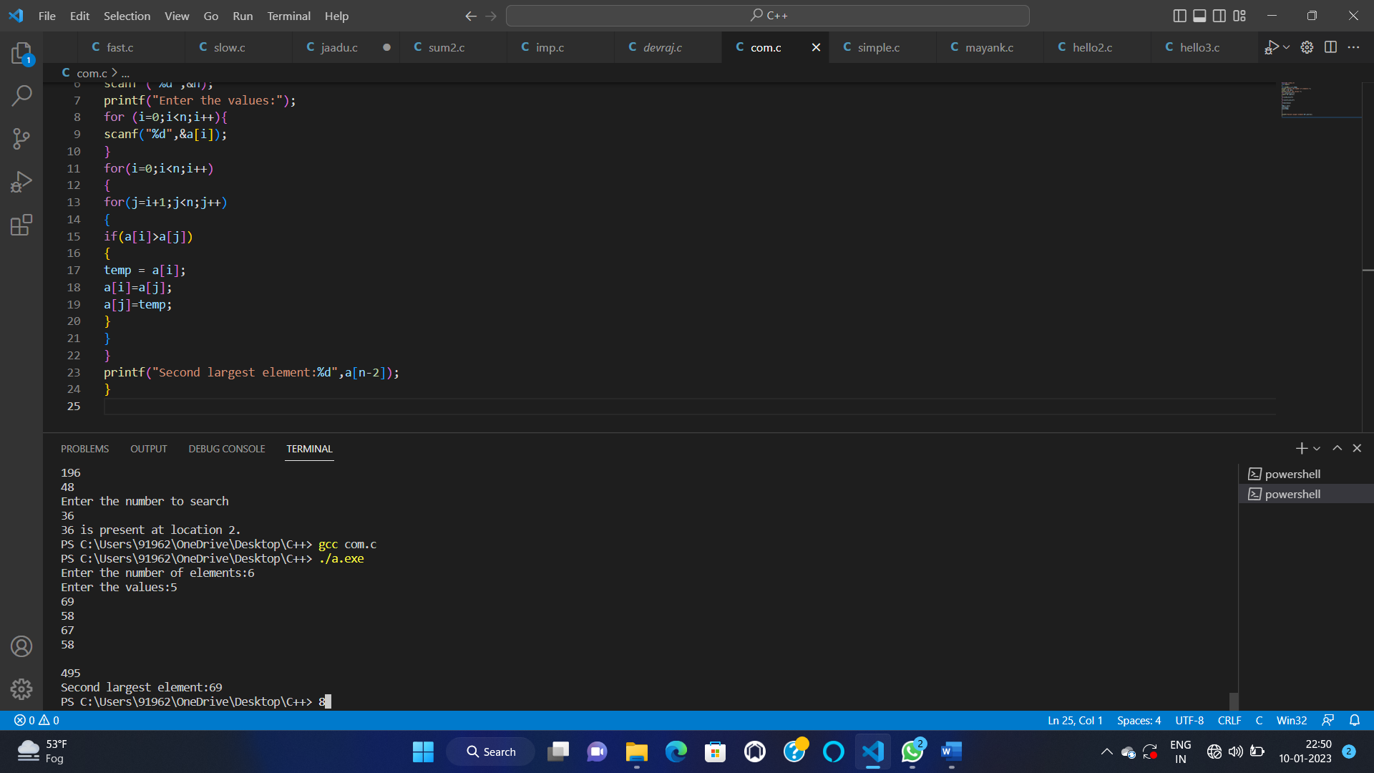

37—-

#include <stdio.h>

#define MAX_SIZE 100

int main()

{

int arr[MAX_SIZE];

int i, j, size, count = 0;

printf("Enter size of the array : ");

scanf("%d", &size);

printf("Enter elements in array : ");

for(i=0; i<size; i++)

{

scanf("%d", &arr[i]);

}

for(i=0; i<size; i++)

{

for(j=i+1; j<size; j++)

{

if(arr[i] == arr[j])

{

count++;

break;

}

}

}

printf("\nTotal number of duplicate elements found in array = %d", count);

return 0;

}

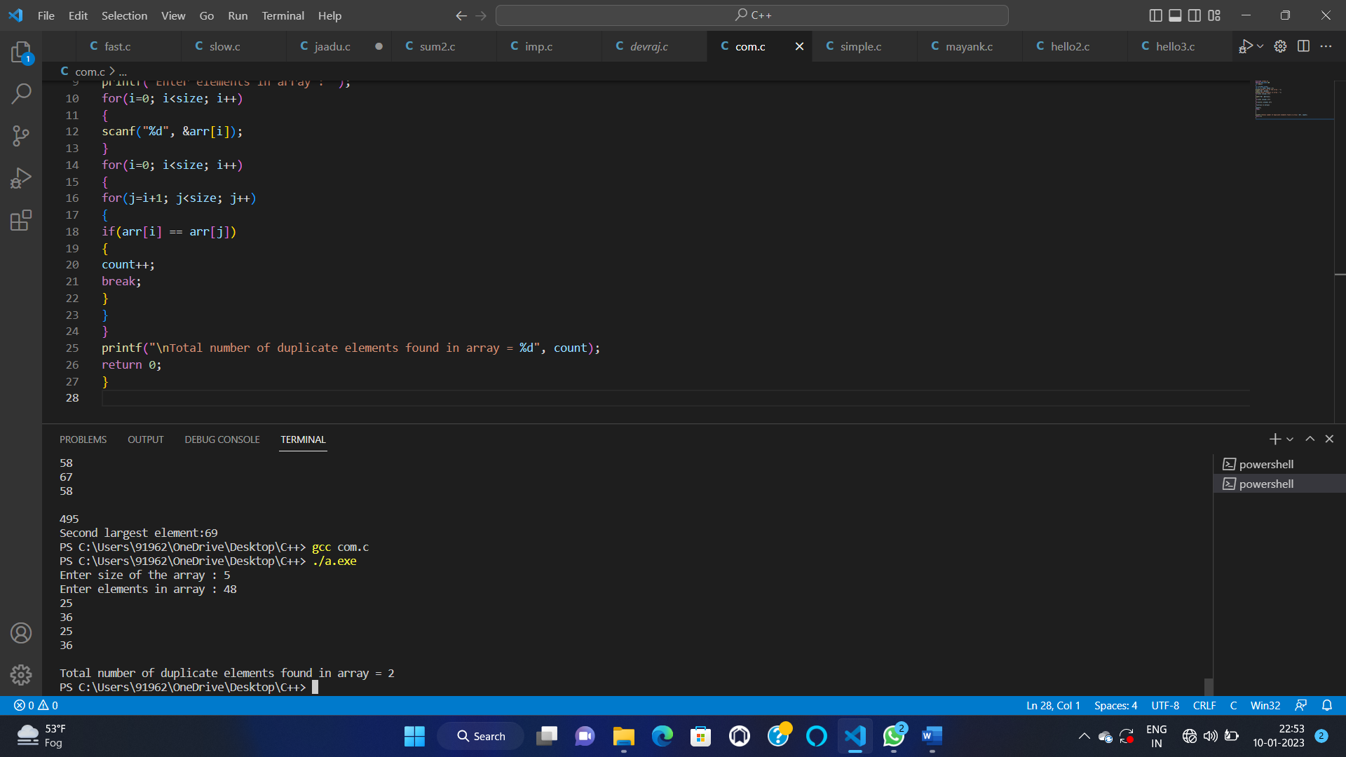

38—

#include <stdio.h>

#define SIZE 3

int main()

{

int A[SIZE][SIZE];

int num, row, col;

printf("Enter elements in matrix of size %dx%d: \n", SIZE, SIZE);

for(row=0; row<SIZE; row++)

{

for(col=0; col<SIZE; col++)

{

scanf("%d", &A[row][col]);

}

}

printf("Enter any number to multiply with matrix A: ");

scanf("%d", &num);

for(row=0; row<SIZE; row++)

{

for(col=0; col<SIZE; col++)

{

A[row][col] = num * A[row][col];

}

}

printf("\nResultant matrix c.A = \n");

for(row=0; row<SIZE; row++)

{

for(col=0; col<SIZE; col++)

{

printf("%d ", A[row][col]);

}

printf("\n");

}

return 0;

}

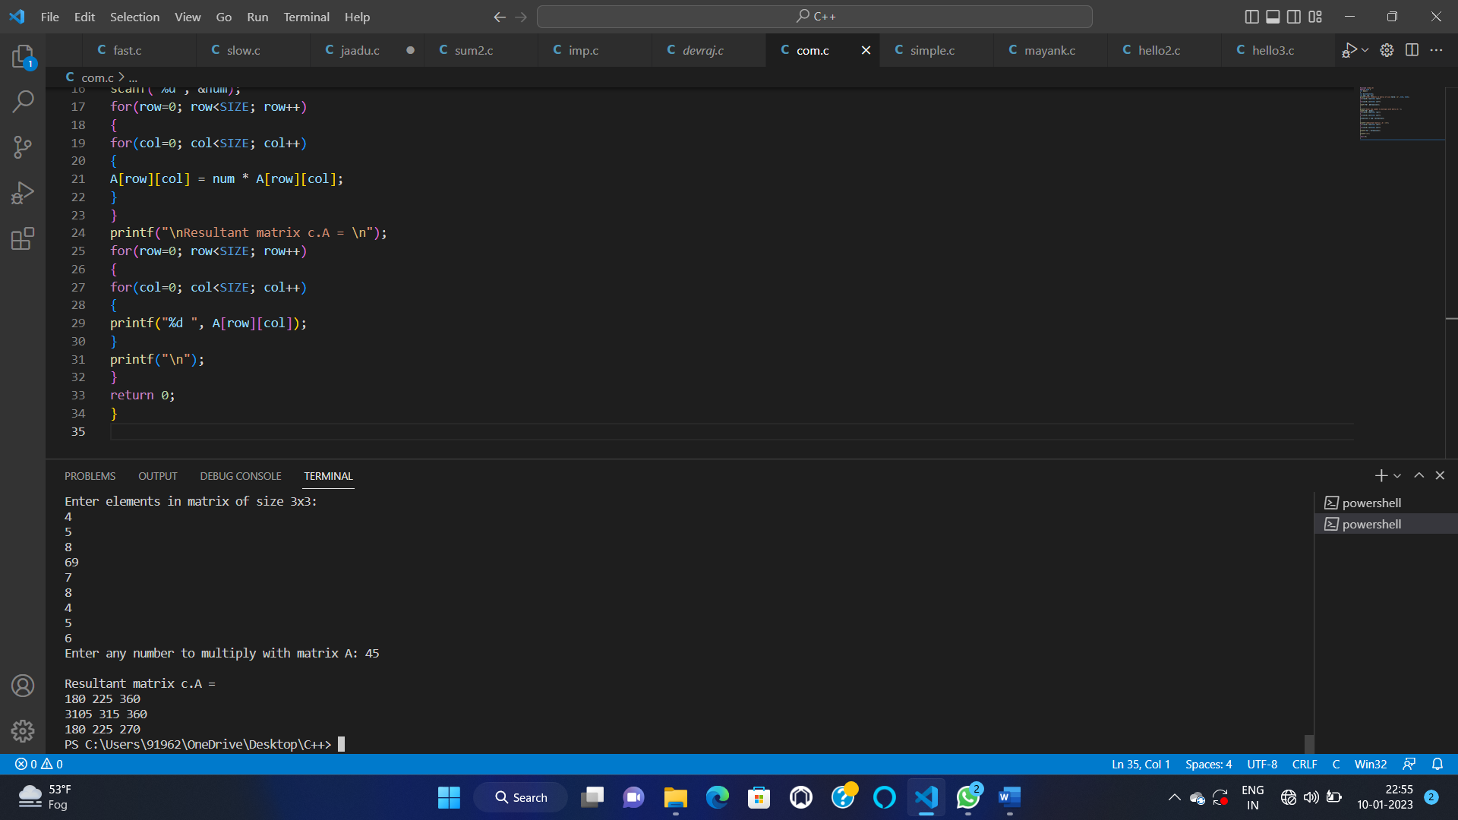

39—

#include <stdio.h>

#define SIZE 3

int main()

{

int A[SIZE][SIZE];

int row, col, sum = 0;

printf("Enter elements in matrix of size %dx%d: \n", SIZE, SIZE);

for(row=0; row<SIZE; row++)

{

for(col=0; col<SIZE; col++)

{

scanf("%d", &A[row][col]);

}

}

for(row=0; row<SIZE; row++)

{

sum = sum + A[row][row];

}

printf("\nSum of diagonal = %d", sum);

return 0;

}

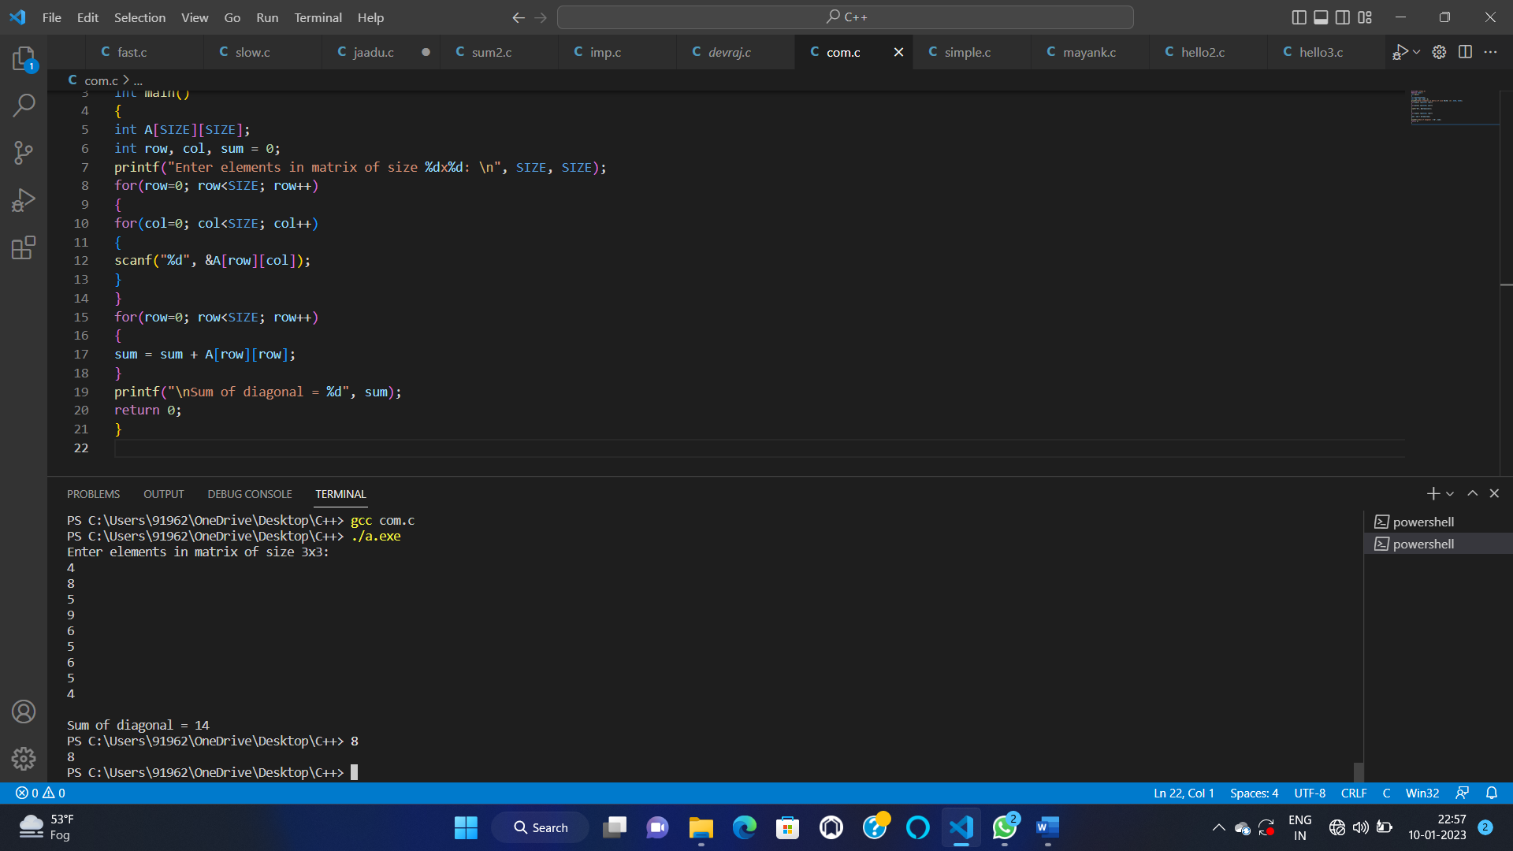

40–

#include <stdio.h>

int main() {

int a[10][10], transpose[10][10], r, c;

printf("Enter rows and columns: ");

scanf("%d %d", &r, &c);

printf("\nEnter matrix elements:\n");

for (int i = 0; i < r; ++i)

for (int j = 0; j < c; ++j) {

printf("Enter element a%d%d: ", i +1, j +1);

scanf("%d", &a[i][j]);

}

printf("\nEntered matrix: \n");

for (int i = 0; i < r; ++i)

for (int j = 0; j < c; ++j) {

printf("%d ", a[i][j]);

if (j == c - 1)

printf("\n");

}

for (int i = 0; i < r; ++i)

for (int j = 0; j < c; ++j) {

transpose[j][i] = a[i][j];

}

printf("\nTranspose of the matrix:\n");

for (int i = 0; i < c; ++i)

for (int j = 0; j < r; ++j) {

printf("%d ", transpose[i][j]);

if (j == r - 1)

printf("\n");

}

return 0;

}

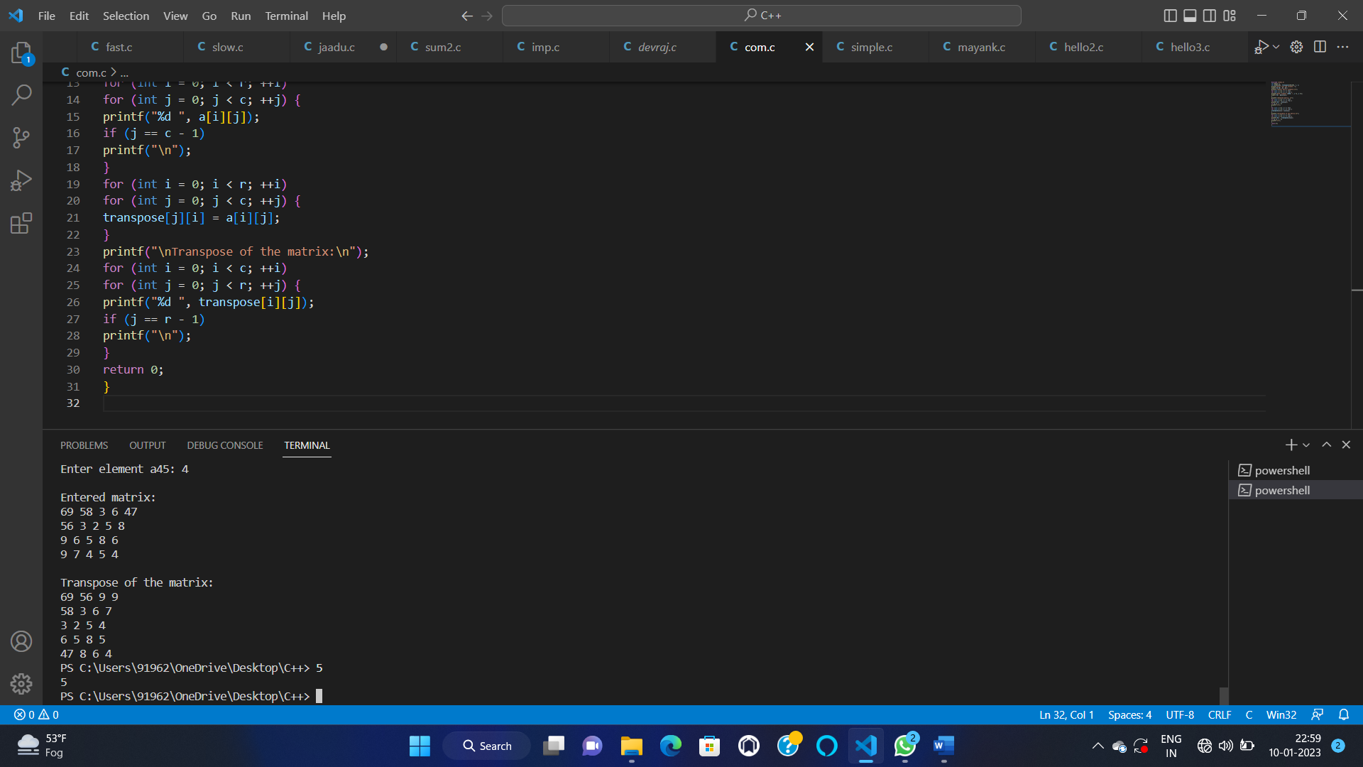

41—

#include <stdio.h>

#define SIZE 3

int main()

{

int A[SIZE][SIZE];

int row, col, isIdentity;

printf("Enter elements in matrix 3x3: \n");

for(row=0; row<SIZE; row++)

{

for(col=0; col<SIZE; col++)

{

scanf("%d", &A[row][col]);

}

}

isIdentity = 1;

for(row=0; row<SIZE; row++)

{

for(col=0; col<SIZE; col++)

{

if(row==col && A[row][col]!=1)

{

isIdentity = 0;

}

else if(row!=col && A[row][col]!=0)

{

isIdentity = 0;

}

}

}

if(isIdentity == 1)

{

printf("\nAn Identity Matrix.\n");

for(row=0; row<SIZE; row++)

{

for(col=0; col<SIZE; col++)

{

printf("%d ", A[row][col]);

}

printf("\n");

}

}

else

{

printf("Not Identity Matrix");

}

return 0;

}

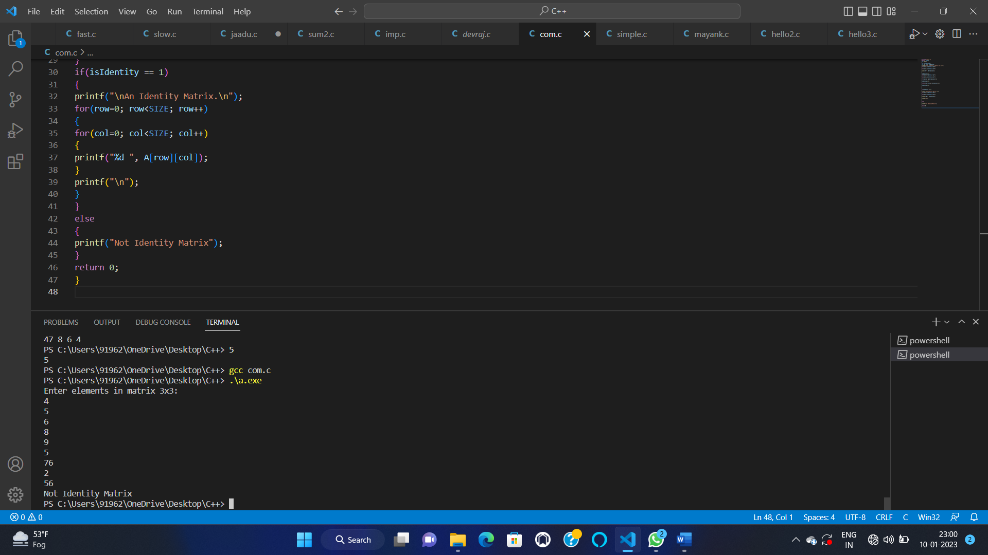

42—-

#include <stdio.h>

#include <stdlib.h>

int main(void)

{

int i, n, j, k;

printf("Enter the size of the first array: ");

scanf("%d", &n);

int arr1[n];

printf("Enter the elements of the first array: \n");

for (i = 0; i < n; i++)

{

scanf("%d", &arr1[i]);

}

printf("Enter the size of the second array: ");

scanf("%d", &k);

int arr2[k];

printf("Enter the elements of the second array: \n");

for (j = 0; j < k; j++)

{

scanf("%d", &arr2[j]);

}

int arr3[n + k];

i = j = 0;

int in;

for (in = 0; in < n + k; in ++)

{

if (i < n && j < k)

{

if (arr1[i] < arr2[j])

{

arr3[in] = arr1[i];

i++;

}

else

{

arr3[in] = arr2[j];

j++;

}

}

else if (i < n)

{

arr3[in] = arr1[i];

i++;

}

else

{

arr3[in] = arr2[j];

j++;

}

}

printf("The merged array is: \n");

for (in = 0; in < n + k; in++)

{

printf("%d ", arr3[in]);

}

printf("\n");

return 0;

}

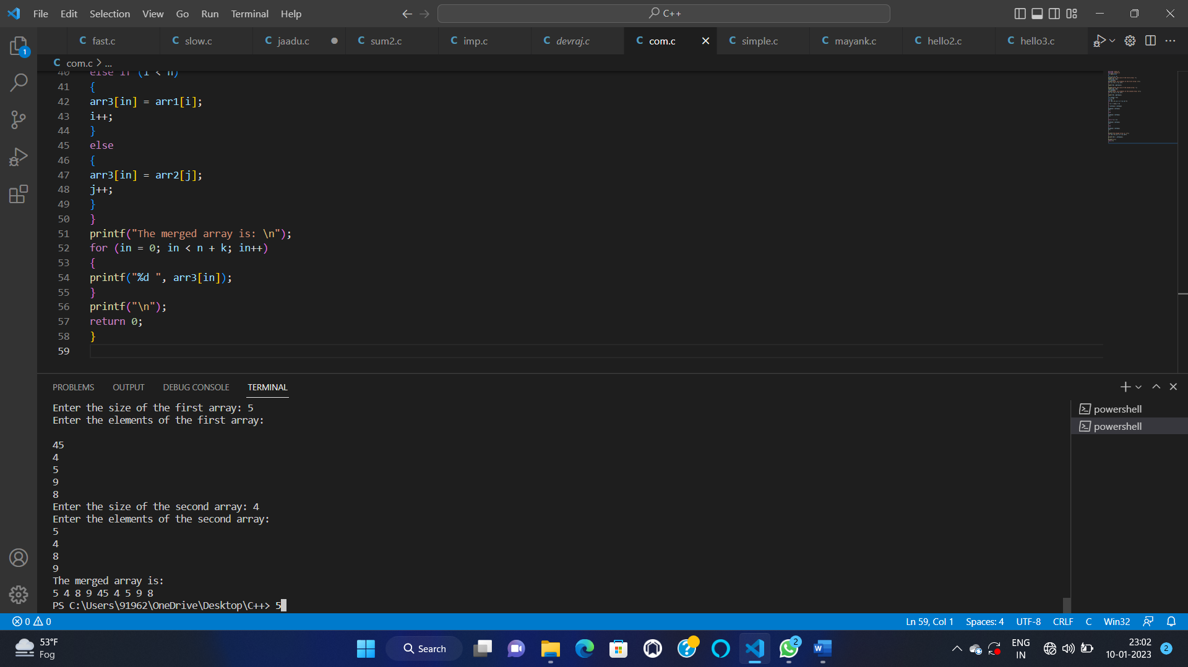

43—

#include<stdio.h>

int main()

{

char name[30];

printf("Enter name: ");

gets(name); //Function to read string from user.

printf("Name: ");

puts(name); //Function to display string.

return 0;

}

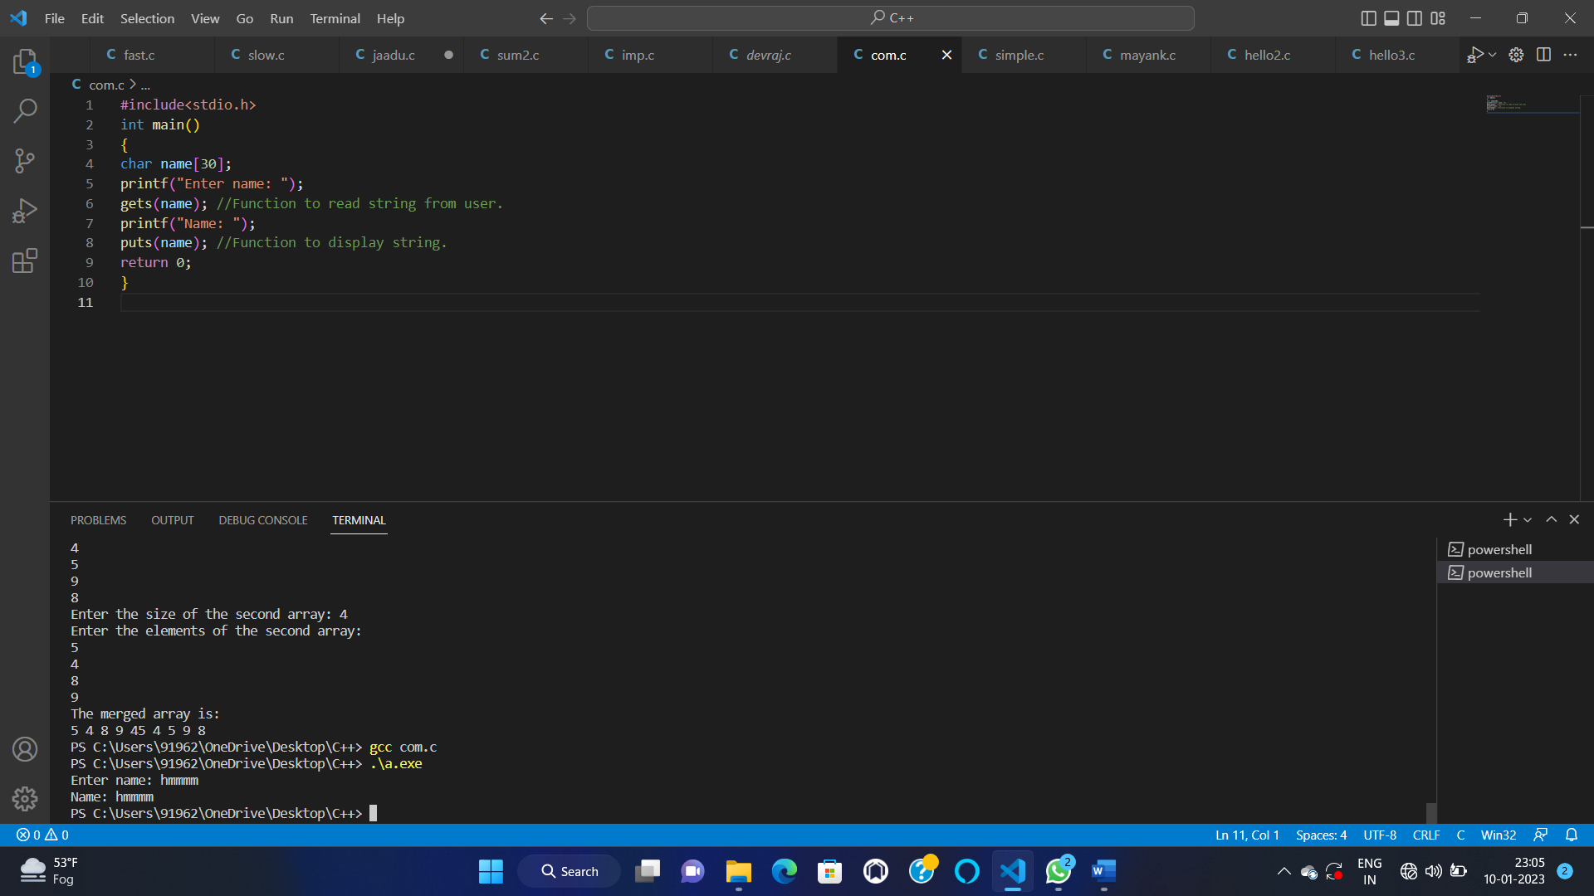

44—

#include <stdio.h>

#include <string.h>

int main()

{

char str[] = { "abbba" };

int l = 0;

int h = strlen(str) - 1;

while (h > l) {

if (str[l++] != str[h--]) {

printf("%s is not a palindrome\n", str);

return 0;

}

}

printf("%s is a palindrome\n", str);

return 0;

}

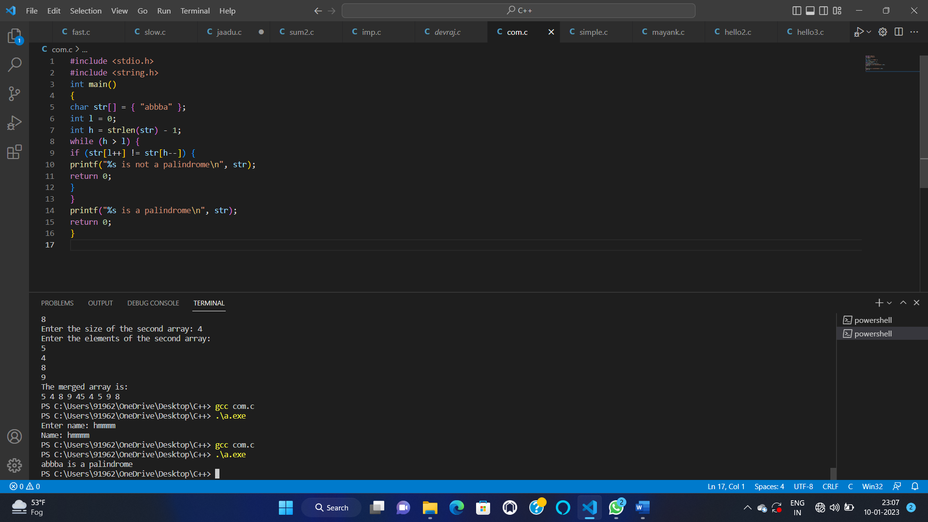

45—

#include <stdio.h>

int main() {

char str[1000], ch;

int count = 0;

printf("Enter a string: ");

fgets(str, sizeof(str), stdin);

printf("Enter a character to find its frequency: ");

scanf("%c", &ch);

for (int i = 0; str[i] != '\0'; ++i) {

if (ch == str[i])

++count;

}

printf("Frequency of %c = %d", ch, count);

return 0;

}

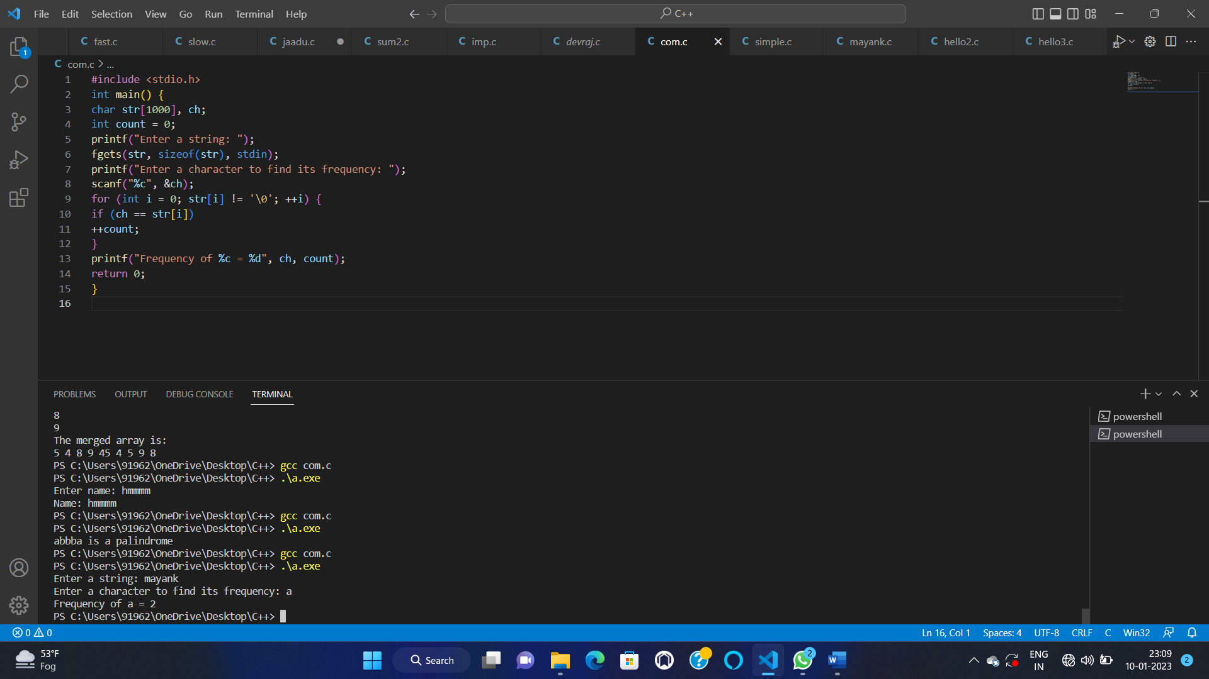

46—-

#include <stdio.h>

int main()

{

float radius, diameter, circumference, area;

printf("Enter radius of circle: ");

scanf("%f", &radius);

diameter = 2 * radius;

circumference = 2 * 3.14 * radius;

area = 3.14 * (radius * radius);

printf("Diameter of circle = %.2f units \n", diameter);

printf("Circumference of circle = %.2f units \n", circumference);

printf("Area of circle = %.2f sq. units ", area);

return 0;

}

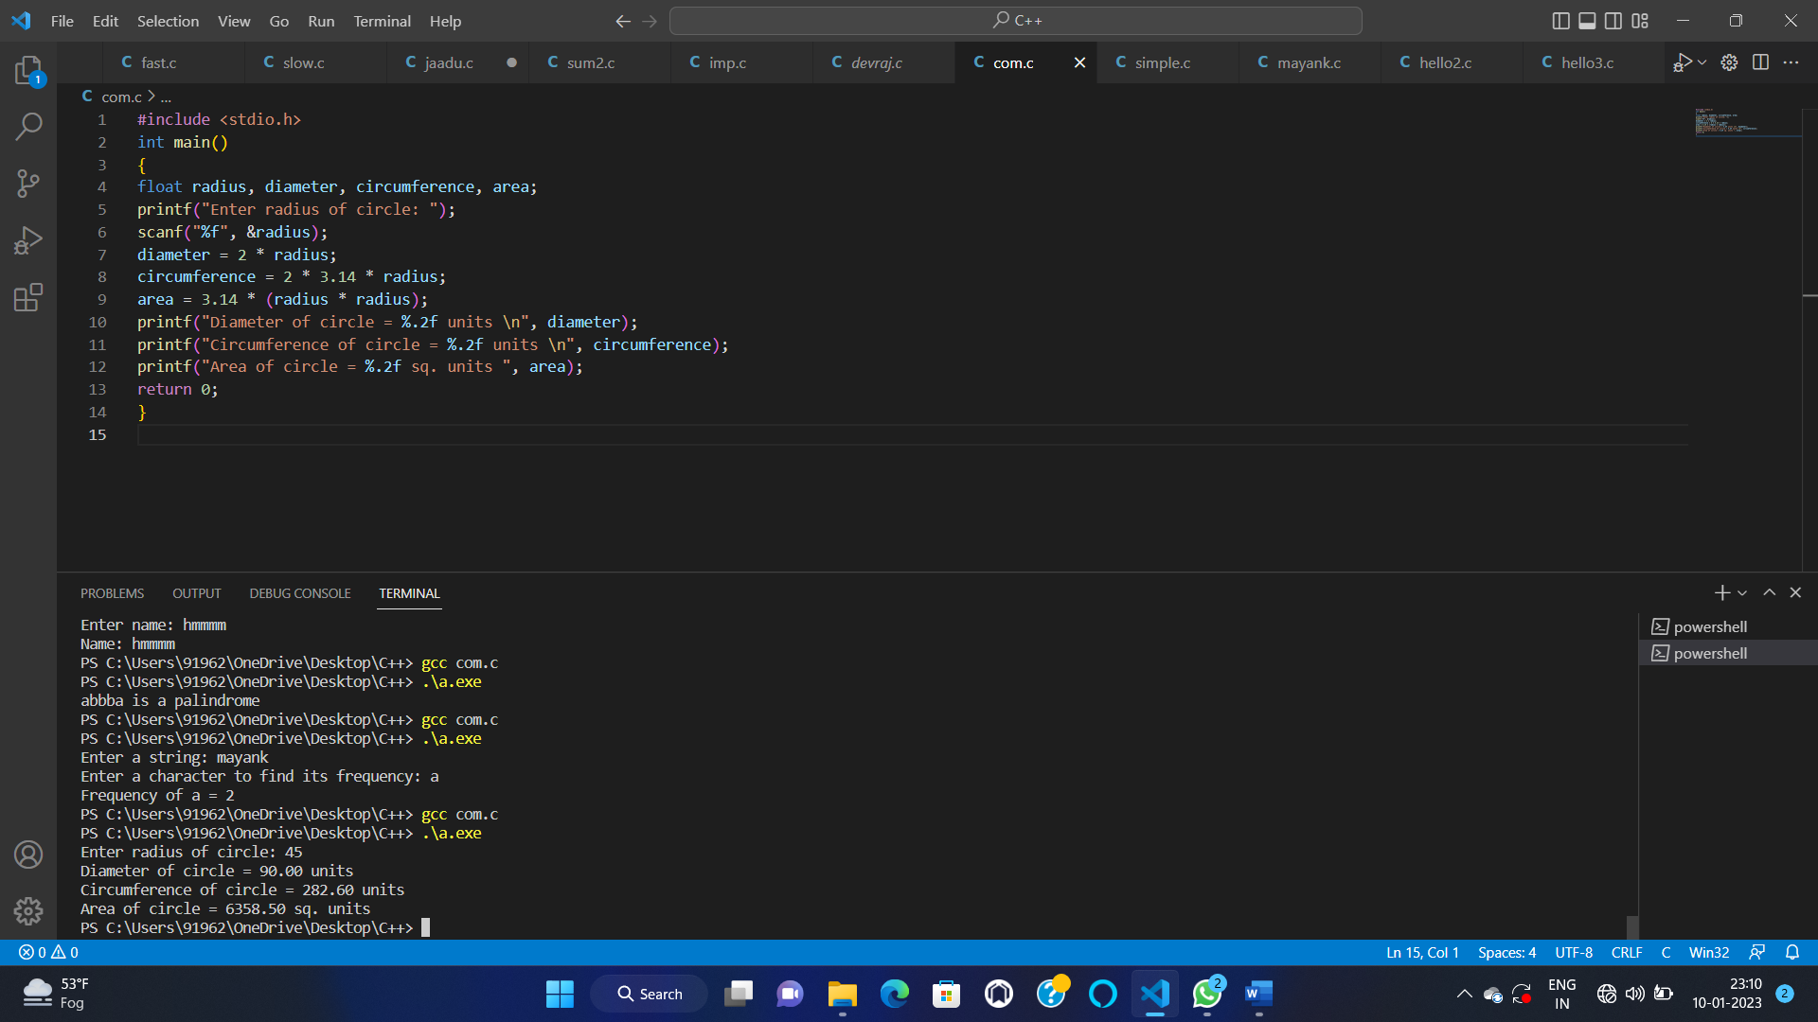

47—

#include <stdio.h>

#include <math.h>

int isPrime(int num);

int isArmstrong(int num);

int isPerfect(int num);

int main()

{

int num;

printf("Enter any number: ");

scanf("%d", &num);

if(isPrime(num))

{

printf("%d is Prime number.\n", num);

}

else

{

printf("%d is not Prime number.\n", num);

}

if(isArmstrong(num))

{

printf("%d is Armstrong number.\n", num);

}

else

{

printf("%d is not Armstrong number.\n", num);

}

if(isPerfect(num))

{

printf("%d is Perfect number.\n", num);

}

else

{

printf("%d is not Perfect number.\n", num);

}

return 0;

}

int isPrime(int num)

{

int i;

for(i=2; i<=num/2; i++)

{

if(num%i == 0)

{

return 0;

}

}

return 1;

}

int isArmstrong(int num)

{

int lastDigit, sum, originalNum, digits;

sum = 0;

originalNum = num;

digits = (int) log10(num) + 1;

while(num > 0)

{

lastDigit = num % 10;

sum = sum + round(pow(lastDigit, digits));

num = num / 10;

}

return (originalNum == sum);

}

int isPerfect(int num)

{

int i, sum, n;

sum = 0;

n = num;

for(i=1; i<n; i++)

{

if(n%i == 0)

{

sum += i;

}

}

return (num == sum);

}

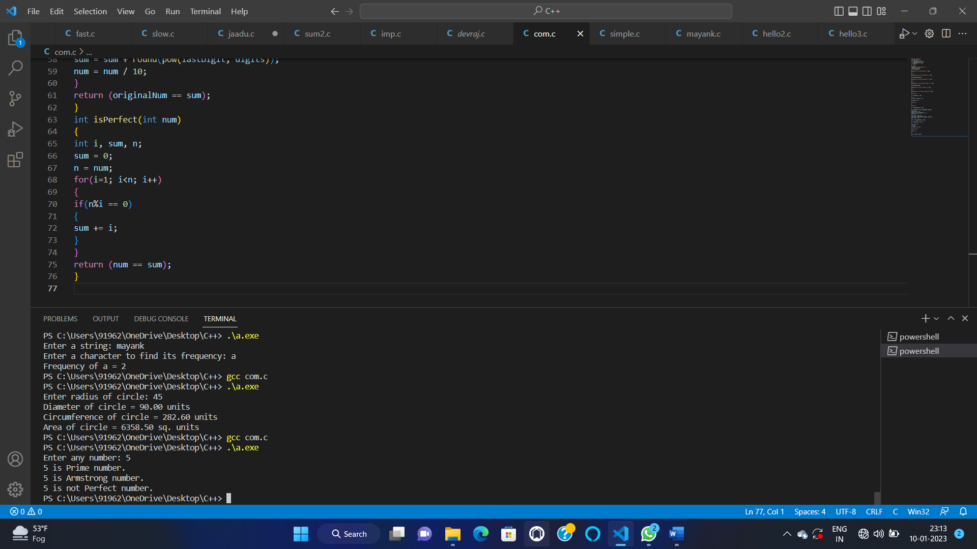

48—

#include <stdio.h>

int main()

{

int first, second, *p, *q, sum;

printf("Enter two integers to add\n");

scanf("%d%d", &first, &second);

p = &first;

q = &second;

sum = *p + *q;

printf("Sum of the numbers = %d\n", sum);

return 0;

}

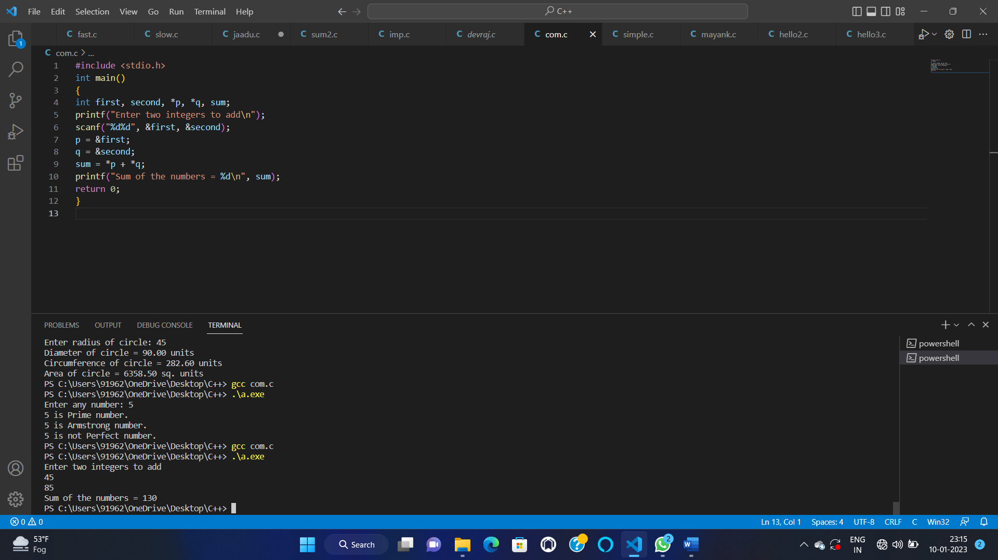

49—

#include<stdio.h>

void swap(int *,int *);

void main( )

{

int n1,n2;

printf("Enter the two numbers to be swapped\n");

scanf("%d%d",&n1,&n2);

printf("\nThe values of n1 and n2 in the main function before calling the swap function are

n1=%d n2=%d",n1,n2);

swap(&n1,&n2);

printf("\nThe values of n1 and n2 in the main function after calling the swap function are

n1=%d n2=%d",n1,n2);

}

void swap(int *n1,int *n2)

{

int temp;

temp=*n1;

*n1=*n2;

*n2=temp;

printf("\nThe values of n1 and n2 in the swap function after swapping are n1=%d

n2=%d",*n1,*n2);

}

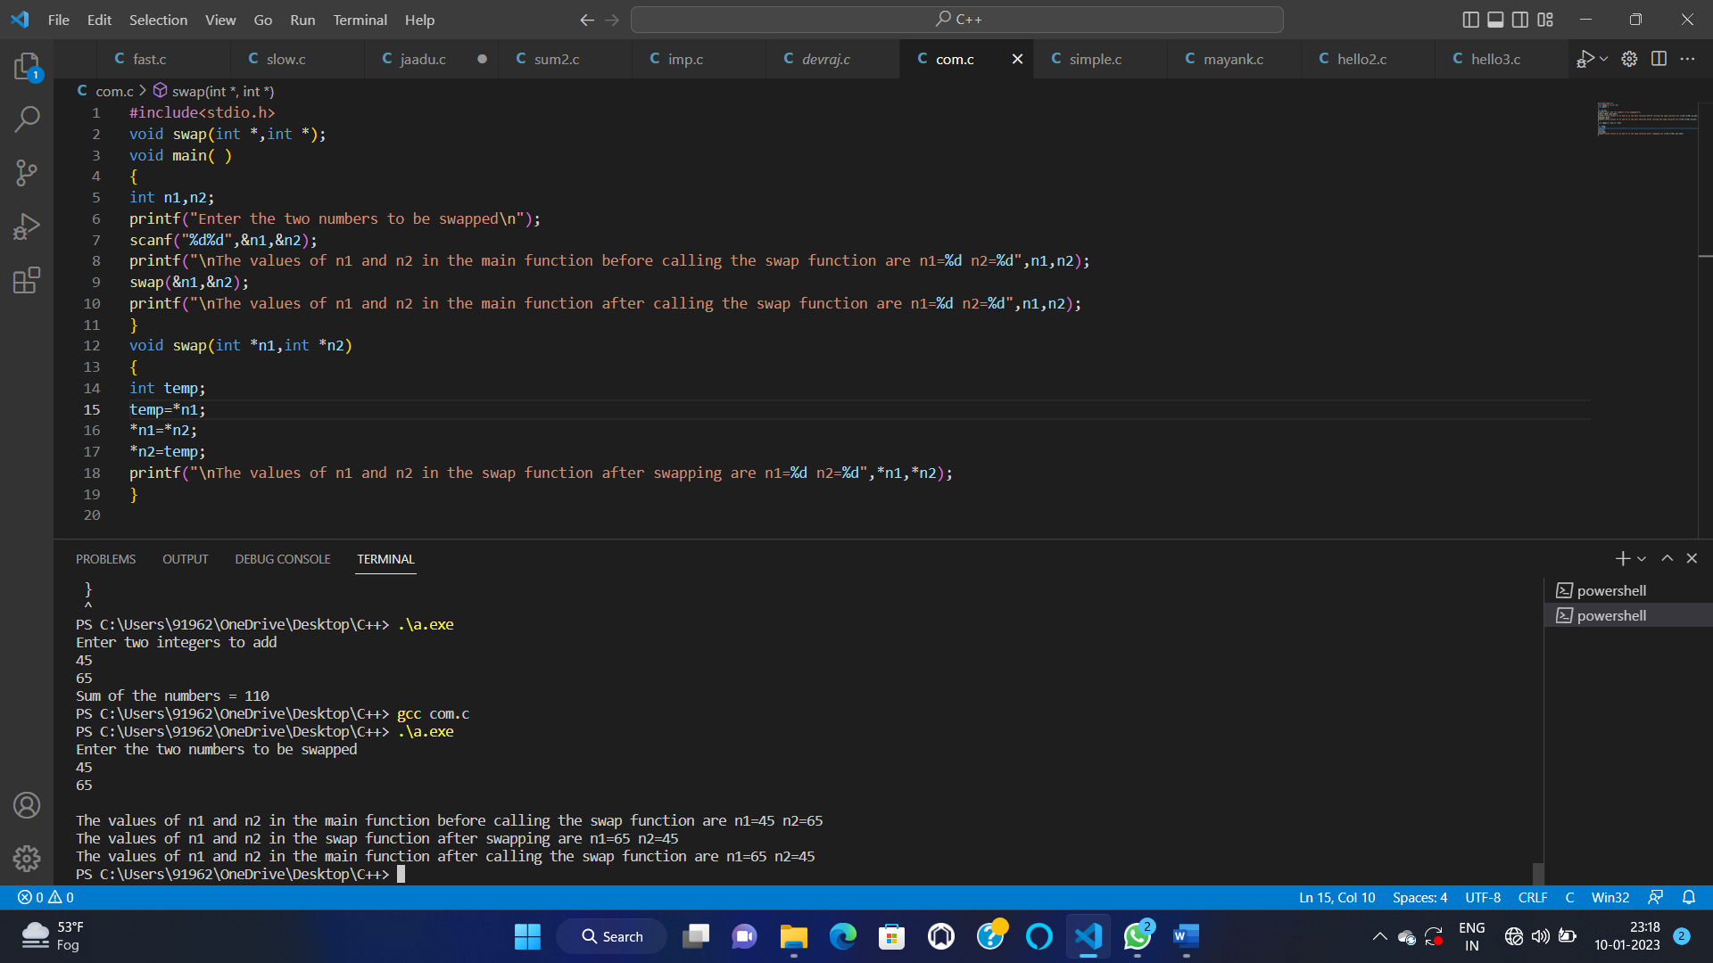

50–

#include <stdio.h>

#define MAX_SIZE 100

void printArray(int arr[], int size);

int main()

{

int source_arr[MAX_SIZE], dest_arr[MAX_SIZE];

int size, i;

int *source_ptr = source_arr;

int *dest_ptr = dest_arr;

int *end_ptr;

printf("Enter size of array: ");

scanf("%d", &size);

printf("Enter elements in array: ");

for (i = 0; i < size; i++)

{

scanf("%d", (source_ptr + i));

}

end_ptr = &source_arr[size - 1];

printf("\nSource array before copying: ");

printArray(source_arr, size);

printf("\nDestination array before copying: ");

printArray(dest_arr, size);

while(source_ptr <= end_ptr)

{

*dest_ptr = *source_ptr;

source_ptr++;

dest_ptr++;

}

printf("\n\nSource array after copying: ");

printArray(source_arr, size);

printf("\nDestination array after copying: ");

printArray(dest_arr, size);

return 0;

}

void printArray(int *arr, int size)

{

int i;

for (i = 0; i < size; i++)

{

printf("%d, ", *(arr + i));

}

}

AND

#include <stdio.h>

#define MAX_SIZE 100

void printArr(int *arr, int size);

int main()

{

int arr[MAX_SIZE];

int size;

int *left = arr;

int *right;

printf("Enter size of array: ");

scanf("%d", &size);

right = &arr[size - 1];

printf("Enter elements in array: ");

while(left <= right)

{

scanf("%d", left++);

}

printf("\nArray before reverse: ");

printArr(arr, size);

left = arr;

while(left < right)

{

*left ^= *right;

*right ^= *left;

*left ^= *right;

left++;

right--;

}

printf("\nArray after reverse: ");

printArr(arr, size);

return 0;

}

void printArr(int * arr, int size)

{

int * arrEnd = (arr + size - 1);

while(arr <= arrEnd)

{

printf("%d, ", *arr);

arr++;

}

}

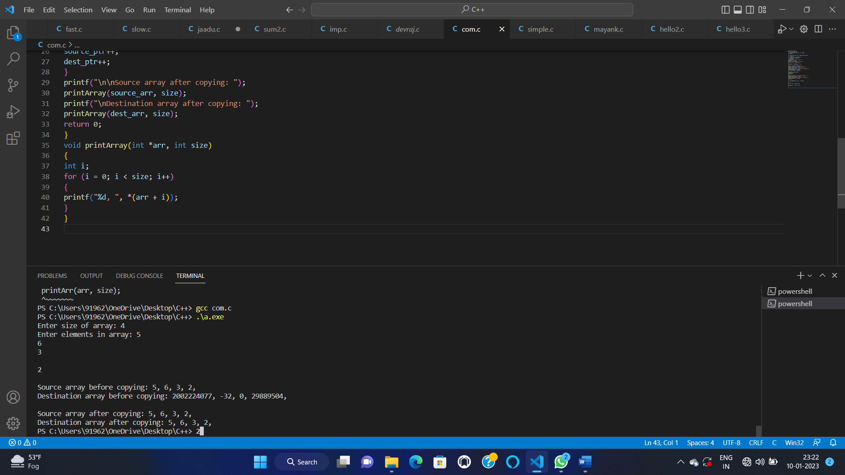

51—

#include <stdio.h>

int main()

{

int i, j, N;

printf("Enter number of rows: ");

scanf("%d", &N);

for(i=1; i<=N; i++)

{

for(j=1; j<=N; j++)

{

printf("*");

}

printf("\n");

}

return 0;

}

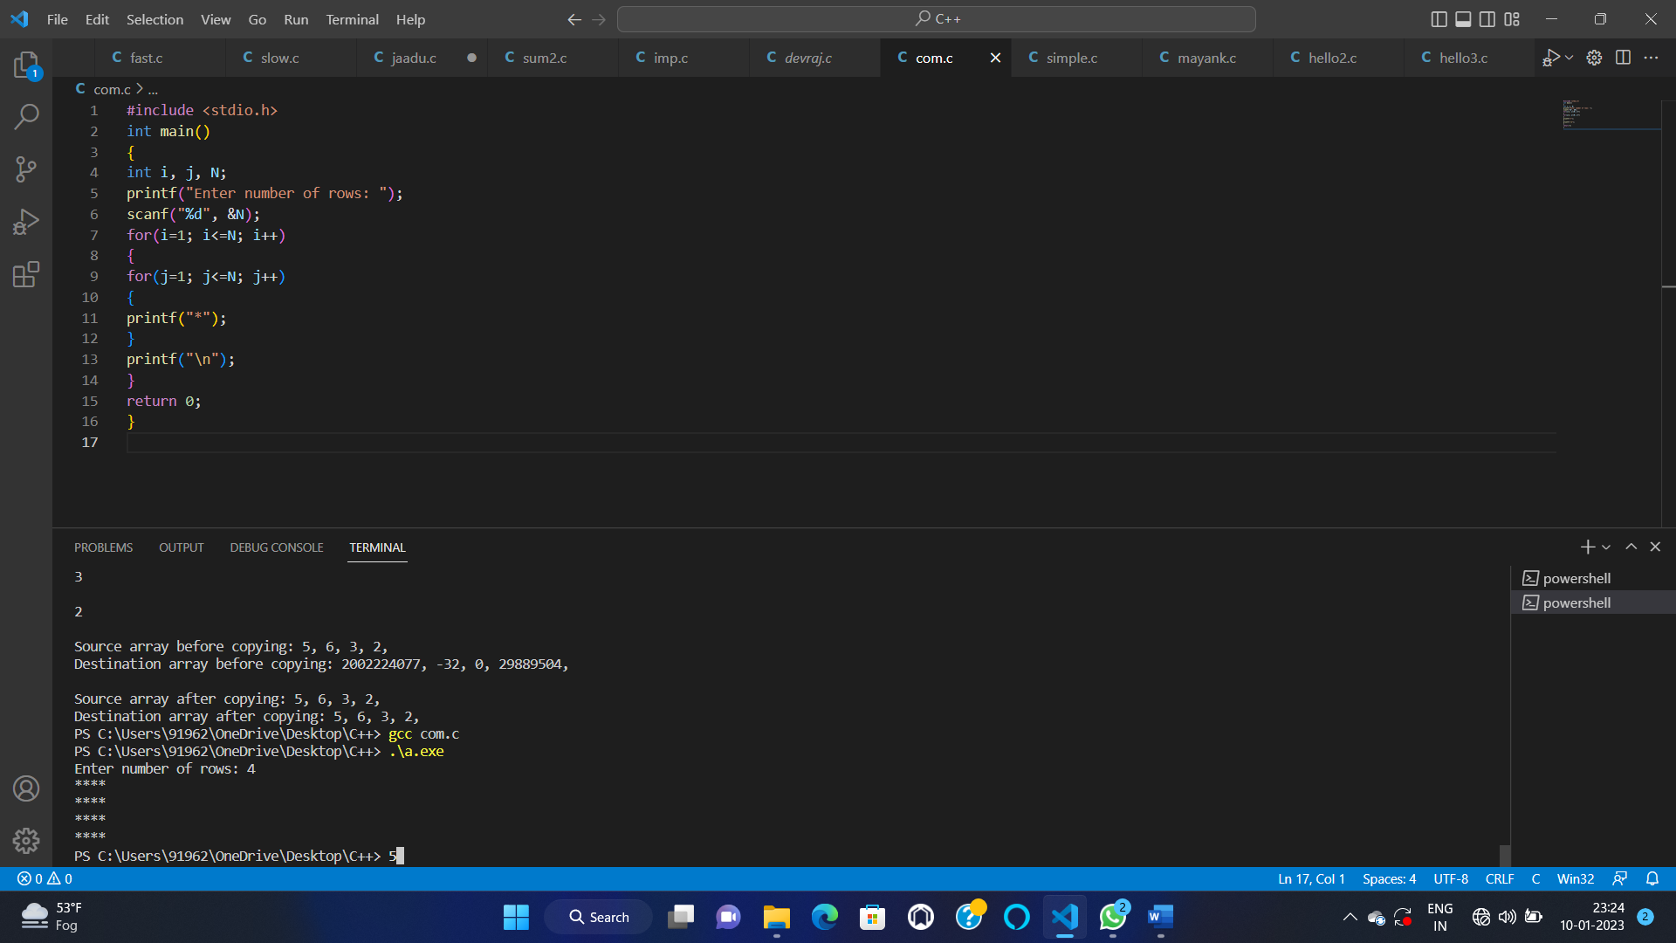

52—

#include <stdio.h>

int main()

{

int i, j, N;

printf("Enter number of rows: ");

scanf("%d", &N);

for(i=1; i<=N; i++)

{

for(j=1; j<=N; j++)

{

if(i==1 || i==N || j==1 || j==N)

{

printf("*");

}

else

{

printf(" ");

}

}

printf("\n");

}

return 0;

}

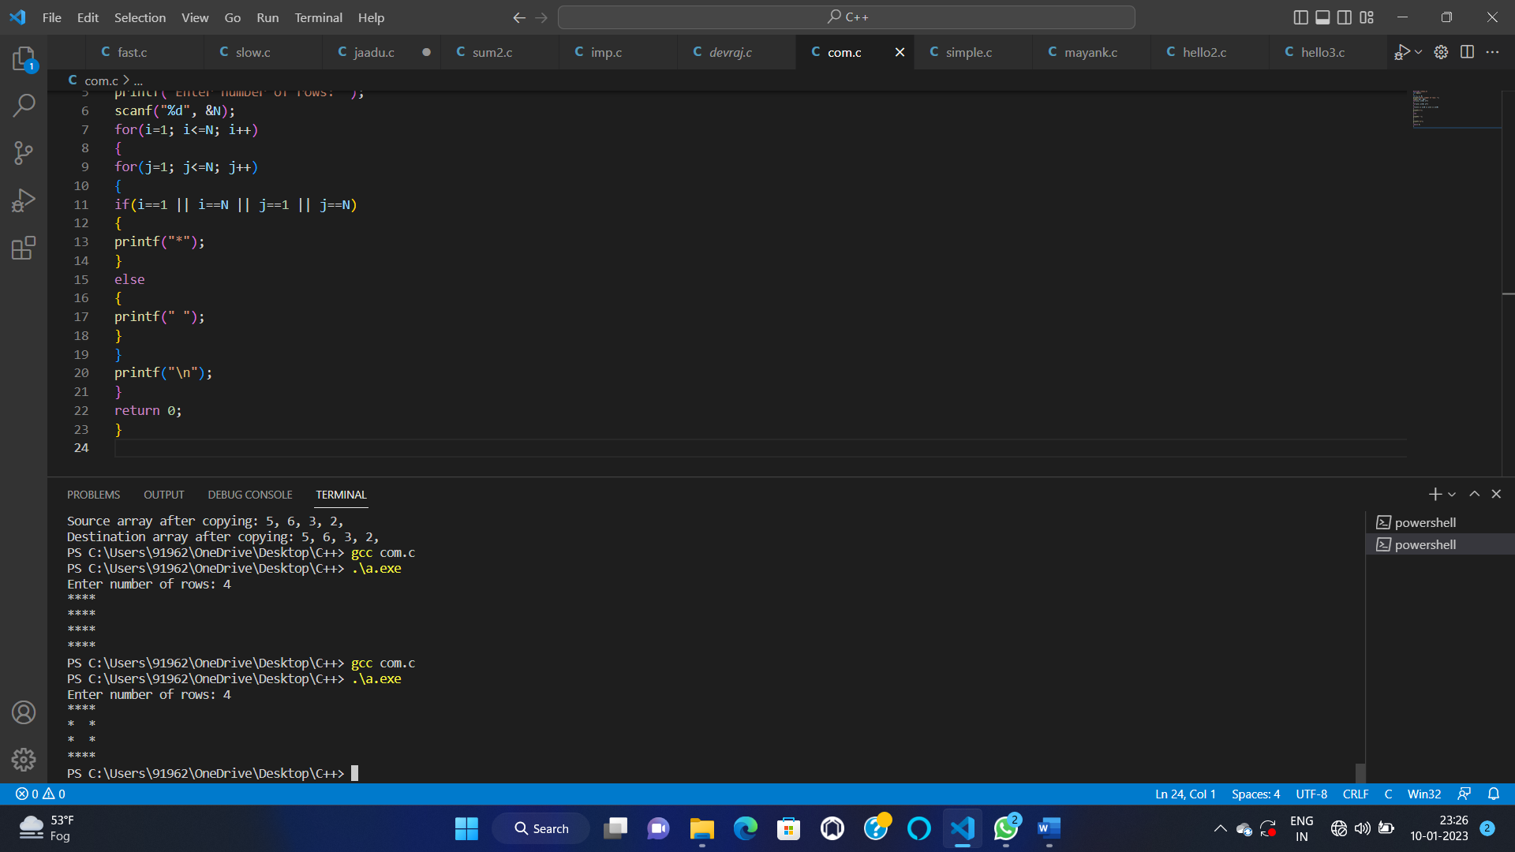

53—

#include <stdio.h>

int main()

{

int i, j, N;

printf("Enter number of rows: ");

scanf("%d", &N);

for(i=1; i<=N; i++)

{

for(j=1; j<=N; j++)

{

if(i==1 || i==N || j==1 || j==N || i==j || j==(N - i + 1))

{

printf("*");

}

else

{

printf(" ");

}

}

printf("\n");

}

return 0;

}

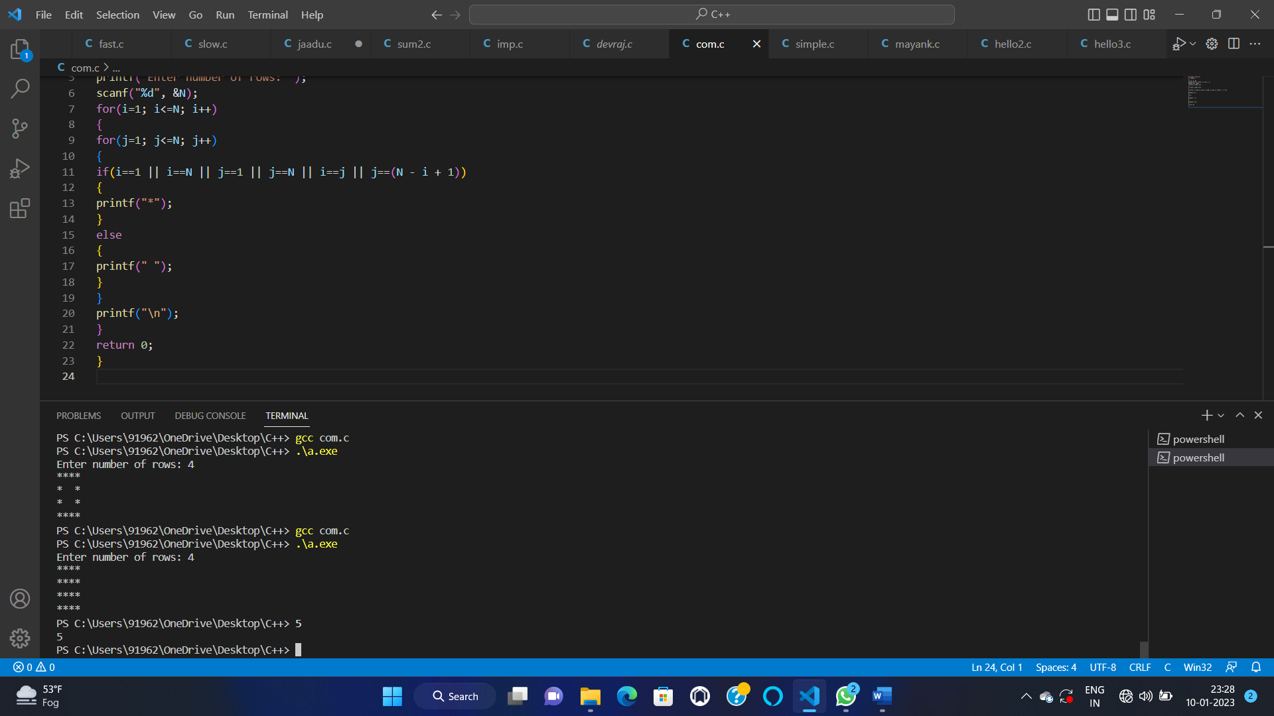

54—

#include <stdio.h>

int main()

{

int i, j, rows;

printf("Enter rows: ");

scanf("%d", &rows);

for(i=1; i<=rows; i++)

{

for(j=1; j<=rows - i; j++)

{

printf(" ");

}

for(j=1; j<=rows; j++)

{

printf("*");

}

printf("\n");

}

return 0;

}

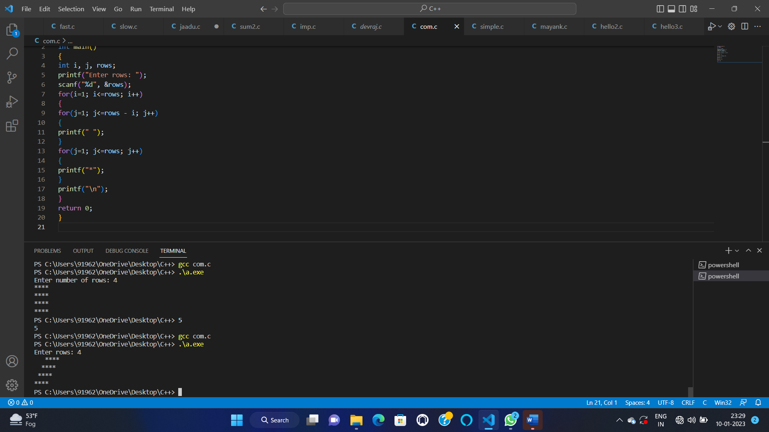

55—-

#include <stdio.h>

int main()

{

int i, j, rows;

printf("Enter rows : ");

scanf("%d", &rows);

for(i=1; i<=rows; i++)

{

for(j=1; j<=rows-i; j++)

{

printf(" ");

}

for(j=1; j<=rows; j++)

{

if(i==1 || i==rows || j==1 || j==rows)

printf("*");

else

printf(" ");

}

printf("\n");

}

return 0;

}

